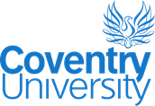 | Investigation of the Impact of Occupant Behavior on Building Performance in the UK and China  June 3 —5, 2019  Engineering & Computing Building  Coventry University, UK | 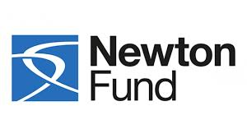
Event Overview
To meet urgent energy reduction goals, innovation in the construction and use of buildings is essential. Unfortunately, considering technological solutions and innovations in building materials is just not enough. To address this, the workshop will facilitate the sharing of complementary technologies such as occupant behavior models, building performance simulations and computational techniques etc. It will contribute to improve energy performance and bridging the gap of actual and predicted energy use of buildings, leveraging the human factor to the same extent as technology innovations.

The aims of the workshop are:
1) Review of contemporary research in China and the UK on building energy use, occupant behavior studies and building performance simulation through keynote speeches, discussions and brainstorming.
2) Further understanding of occupants’ behavior, research methodologies and the possibility of transfer to low-carbon behavior.
3) With case studies, research findings and relevant experiences contributing to the behavior model and computational techniques for building performance simulation will be identified for further research direction for the ECRs.
4) Strengthen the research capacity through the UK-China collaboration by networking opportunities, highlighting the expertise of all ECRs, the facilities and support from their home institutes.

We are inviting (i) Designers, researchers and Early Career Researchers experienced in low carbon technologies, built environment, building performance, and occupants behavior; (ii) Housing Sector planners; and (iii) Policy makers, from the UK and China, to attend this workshop.

(i) Knowledge Exchange and Information Sharing; (ii) Current and Potential Technological Solutions (Built Environment, Low Carbon Technologies applied in Buildings, Occupant Behavior); (iii) Renewable Energy and Energy Storage; (iv) Case Studies from both sides on Policy, Building Performance and potential solutions and (v) Future collaborations.

During the workshop we will create a working group of participants and develop a dedicated blog, to share their relevant research findings. All participants will have access to a mentor during and after the workshop. The costs of travel, accommodation and meals during the workshop will be covered.

Newton Research Links
This workshop is being delivered as a part of the Newton Researcher Links workshop project between Coventry University and Tsinghua University. Newton Researcher Links are designed to provide financial support to bring together a UK and China cohort to take part in a workshop focusing on building links for future collaboration and enhancing the researchers’ career opportunities.

The Newton Fund is a £375 million fund (£75 million a year for five years) which, through science and innovation partnerships aims to promote the economic development and welfare of low income populations in developing countries. The Fund is overseen by the Department for Businesses Innovation and Skills (BIS) and delivered through 15 delivery partners in collaboration with 15 partnering countries.

How to Apply
Researchers, Representatives, Planners and Policy Makers from the UK and China are invited to apply to attend the workshop. We are inviting researchers with experience in the following domains: Low-Carbon Technologies, Built Environment, and Occupants Behavior.

Applicants are requied to complete the attached Workshop Application Form. Your submission must be in PDF format with all fonts embedded.

The full application below must be completed and submitted by 1st May 2019 to Cheng Zeng on zengc3@uni.coventry.ac.uk and Ashish Shukla on ab4322@coventry.ac.uk.

Successful applicants will receive expenses covering travel and accommodation expenses incurred for attending the conference. This stipend is provide by the Newton Researcher Links grant.

Selection Criteria
The organisation will select 17 Participants from UK and 17 from China. The selection criteria are:
- Less than 10 years since being awarded the PhD
- Experience and relevance of the applicant's research area to the workshop
- Motivation and contribution to the aims of the workshop
- Long term impact expected through the participation in the workshop
- Ability to disseminate workshop's outcomes
- Participants must have a research or academic position

Important Dates
Submission deadline: 1st May 2019
Notification of acceptance: 15th May 2019
Workshop dates: June 3-5, 2019

Venue
Coventry University – Engineering & Computing Building
The Faculty of Engineering, Environment and Computing is situated in the birthplace of the British motor industry and the historical heart of UK manufacturing. Our students and staff are impacting on tomorrow’s challenges to reinforce our global reputation for research and teaching.

The Faculty is comprised of three Schools:
+ School of Computing, Electronics and Mathematics
+ School of Energy, Construction and Environment
+ School of Mechanical, Aerospace and Automotive Engineering

We are firmly focused on preparing students for successful careers, in the context of industry’s current and future demands. Experience our strong tradition of business-focused education and research, working with some of the biggest names in industry, including Jaguar Land Rover, GE Aviation, Cummins and Intel.

Our innovative activity-led learning approach is internationally recognised and has shaped the unique culture of our forward-facing Faculty in its £55m state-of-the art building. We’re inspiring people to study in a broad range of disciplines, in order to widen perception about how engineering and computing can impact on worldwide cultural development. Through original approaches from world-leading experts, we aim for our research to make a tangible difference to the way we live. The Faculty encourages PhD studentships and internships to run across all areas of study - we are proud to reinvest in our students and graduates.

Organisation
Coordinators
Prof. Shuli Liu, Coventry University, UK
Dr. Da Yan, Tsinghua University, China

Mentors
Dr. Ashish Shukla, Coventry University, UK
Dr. Mahroo Eftekhari, Loughborough University, UK
Prof. Hongsan Sun, Tsinghua University, China
Prof. Fu-Yun Zhao, Wuhan University, China

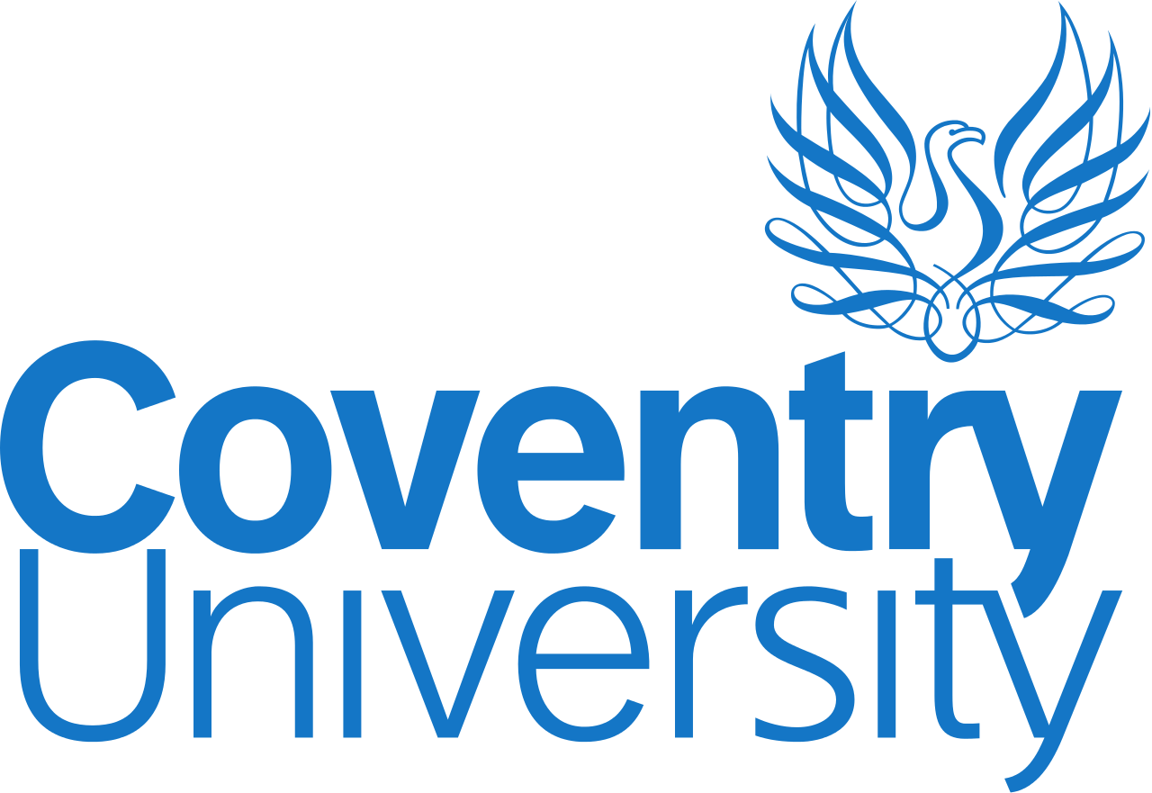 | 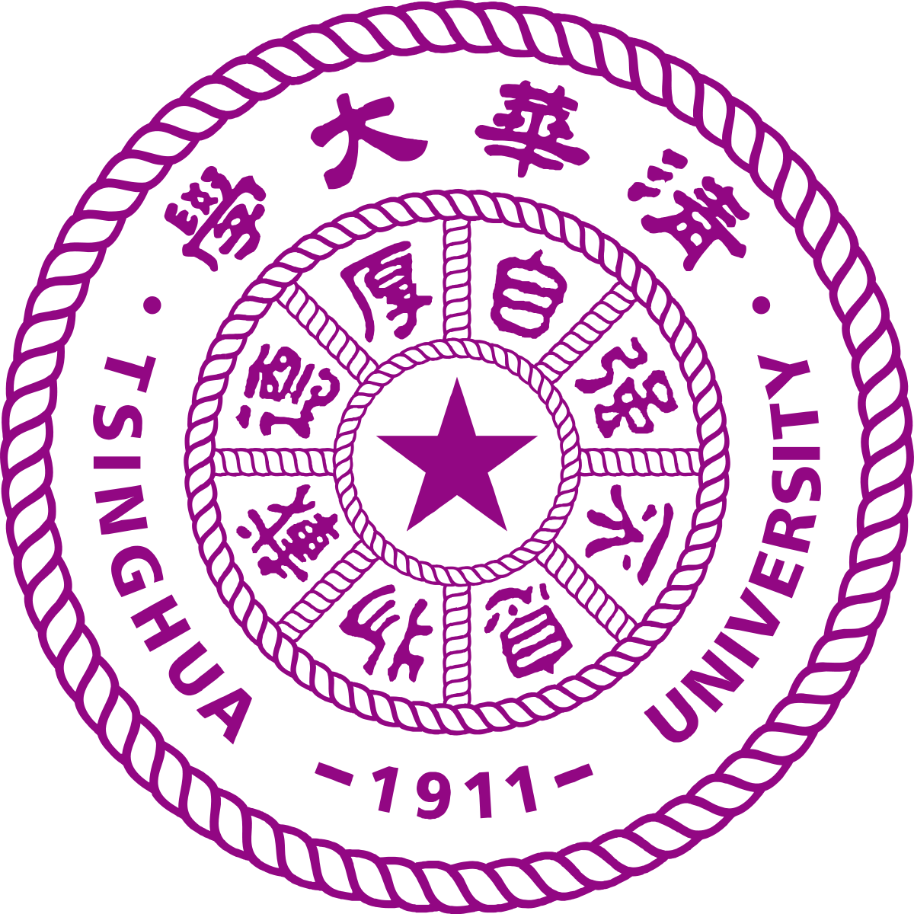

Workshop Application Form

1. Applicant
Name and title
Gender (for statistical purposes. This will not affect choice of participants)
Position and institution
Postal address
Email
Phone number
Brief CV (academic
career, publications,
markers of esteem,
and any other relevant
information) – no more
than 1⁄2 page of A4

2. Abstract - Please give a summary of your area of research (max 100 words)

3. Please describe your motivation to attend the workshop and how the workshop matches your professional development needs (max 100 words)

4. Please describe the expected impact of your participation to the workshop on your personal and professional development, including your ability to work on an international level (max 100 words)

5. Please indicate how you will disseminate the outcomes of the workshops and the new knowledge/skills you have acquired (max 100 words)

6. Workshops will take place in English as standard. Please indicate your ability to work and communicate in English
Native speaker |  | Good
Excellent |  | Need support

7. Please use this space to give any additional information that you feel is relevant for the application. (max 100 words)

