



**Identifying and Understanding Inequalities in Child Welfare Intervention Rates: Comparative studies in four UK countries.**

**Single country quantitative study report: Wales**

Martin Elliott and Jonathan Scourfield

February 2017



Contents

Summary of key findings 4

Note to readers 6

1. Introduction 7

1.1 Research methods 7

Table 1.1 - Sample as percentage of the population 8

1.2 Demographic profile of the Welsh child population 9

Figure 1.2 - Distribution of Welsh child population (0-17 years) by Welsh Index of Multiple Deprivation (WIMD) decile, Mid-Year population estimate 2014 9

Figure 1.3 - Distribution of the Welsh child population by ethnic group and deprivation quintile 10

Figure 1.4 - Distribution of Welsh child population, by age group and deprivation quintile 11

2. Area-Level Deprivation 12

Figure 2.1 – Child protection and looked-after children rates (adjusted) by deprivation decile, Welsh Index of Multiple Deprivation, 2014 12

3. Gender 14

Figure 3.1 Child protection registration rates (per 10,000) by gender and deprivation decile, Welsh Index of Multiple Deprivation, 2014 14

Figure 3.2 Rates (per 10,000) of all looked-after children by gender and deprivation decile, Welsh Index of Multiple Deprivation, 2014 15

Figure 3.3 Rates (per 10,000) of children looked after not placed with family or friends, by gender and deprivation decile, Welsh Index of Multiple Deprivation, 2014 15

4. Age 16

Figure 4.1 Child protection registrations by age group and deprivation quintile, Welsh Index of Multiple Deprivation, 2014 16

Figure 4.2 all children looked after by age group and deprivation quintile, Welsh Index of Multiple Deprivation, 2014 17

Figure 4.3 Children looked after not placed with parents, relatives or friends, by age group and deprivation quintile, Welsh Index of Multiple Deprivation, 2014 18

5. Ethnicity 19

Table 5.1 Ethnic category by deprivation level for child protection 19

Table 5.2 Ethnic category by deprivation level for all children looked after 19

6. Reason for being on the child protection register 21

Figure 6.1 Abuse category by deprivation quintile for child protection registration, Welsh Index of Deprivation, 2014 21

7. Legal Status of Children in Care 23

Figure 7.1 – Legal status for all children looked-after, by deprivation quintile, Welsh Index of Multiple Deprivation 2014 23

Figure 7.2 – Legal status for children looked after, excluding those placed with parents, relatives and friends by deprivation quintile, Welsh Index of Multiple Deprivation, 2014 24

8. Inverse Intervention Law 25

Figure 8.1 –Child Protection rates in local authorities divided into three deprivation bands (high, medium, low) by deprivation decile. 25

Figure 8.2 – Rates of children looked after in local authorities divided into three deprivation bands (high, medium, low) by deprivation decile. 26

9. Spend 27

Figure 9.1 Total spend per child on Children’s Services in Wales, by local authority deprivation level, comparing 2010-11 with 2014-15 27

Figure 9.2 Total spend per child on Children’s Services in England, by local authority deprivation level, comparing 2010-11 with 2014-15 28

10. Discussion and conclusion 29

References 31

# Summary of key findings

This report is about the connection between social inequality and child welfare interventions. We analysed routine administrative data from Welsh local authorities on the children on child protection registers and in care (looked after) on 31 March 2015. These are the key findings:

* There is a clear social gradient whereby for every level of deprivation the rates of children on child protection registers and looked-after by local authorities increase. This gradient is steeper in Wales than in the other three UK nations.
* There is no statistically significant difference between boys and girls in terms of child protection registration rates at each level of deprivation. Boys are slightly more likely than girls to be looked after and not placed with family or friends, across all levels of deprivation.
* When comparing age groups, we see the opposite pattern for child protection registration and looked-after children. The youngest age group (0-4) are the biggest proportion on child protection registers at every level of deprivation and the proportion then decreases with increasing age. For looked-after children, the age group most strongly represented are 16-17-year-olds and there is a decreasing proportion with decreasing age.
* When differences in child population between ethnic groups are taken into account, for those children whose ethnicity is recorded, the highest rate of both child protection and looked-after children is in mixed ethnicity children. Rates of Black and White children are similar for child protection, but Black rates are higher for looked-after children. Asian children have clearly the lowest rates for both child protection and looked-after children. There is no clear social gradient for Black children in care, with a higher rate in the least deprived 20% of areas than in the least deprived 20%.
* When we consider reason for being on the child protection register, there is a clear social gradient for neglect, physical abuse and emotional abuse. For sexual abuse the pattern is less straightforward, but there are still far more children registered for this category of abuse in the most deprived neighbourhoods than in the least deprived neighbourhoods.
* The legal status of children in care was considered. There was a clear social gradient for all the categories of child protection measures, preparation for adoption, voluntary accommodation and youth justice.
* We wanted to establish whether there was any evidence of an inverse intervention law in Wales, as has been found in England. This is where at any given level of deprivation we see more intervention in local authorities which are less deprived overall. In Wales there is no statistical evidence of an inverse intervention effect.
* Although in England we see a clear reduction in spending per child on Children’s Services between 2010-11 and 2014-15, in Wales there was an increase over this same period. As expected, local authorities which are more deprived overall spent more on Children’s Services.

# Note to readers

Although this report is structured in the same way as those we have produced for Northern Ireland, Scotland and England, most of the data the reports contain cannot be directly compared, because the bulk of each report is based on the Index of Multiple Deprivation for the country in question. These Indices are not identical and the distribution of children across neighbourhoods with different levels of deprivation varies between countries. For example, no child in Northern Ireland lives in a neighbourhood amongst the least deprived 10% in the UK. So each report should be viewed for the information it contains about children’s services *within* each country **not** *between* the countries. One exception in this report is the statement which compares the social gradient in Wales with other countries. This statement is made on the basis of a UK-wide Deprivation Index.

# 1. Introduction

Children’s services across the UK face crises of demand and confidence. A substantial growth in the numbers of children ‘looked-after’ in Wales (rising from 4635 in March 2008 to 5615 in March 2015) has come as austerity policies have posed a serious challenge for local authority budgets and placed sustained pressure on family finances. Successive scandals affecting current and historical cases of systemic abuse have added to demands on services. Such headlines deflect attention from another major issue: very large inequalities in a child’s chances of being on a child protection plan or being ‘looked after’ in state care between and within local authorities, between ethnic groups, and across the four UK countries. Child welfare inequalities occur when children and/or their parents face unequal chances, experiences or outcomes of involvement with child welfare services that are systematically associated with structural social dis/advantage and are unjust and avoidable.

The Child Welfare Inequalities Project (CWIP) set out to study the relationship between area-based inequalities and child welfare intervention rates. By ‘rates’ we mean how many children are in care or on child protection plans per 10,000 child population. This work has been undertaken across the four nations of the UK because an initial pilot study (Bywaters, Brady, Sparks and Bos, 2016) found a strong association between area-based deprivation and child welfare intervention rates in local authorities in the English Midlands. Those authors noted that whereas considerable attention has been paid to inequalities in the health and education fields, in the field of children’s social care, social inequality has become taken for granted.

What follows is a report specifically about Wales, using the Welsh Index of Multiple Deprivation. The report covers patterns of child welfare intervention by gender, age, ethnicity, reason for intervention and legal status, all analysed by levels of deprivation. It also includes consideration of the inverse intervention law identified in the Midlands by Bywaters *et al*. and some findings on variation by local authority.

## 1.1 Research methods

The data used for the study were drawn from two sources, the Children in Need census data on children on the child protection register and the SSDA903 dataset, which is the annual return to Government in relation to children and young people looked after by local authorities. The SSDA903 data were provided by the Data Unit within Welsh Government and the child protection data were supplied by each of the 22 Welsh local authorities individually. All data relate to children that were ‘looked-after’ or on the child protection register on the census date, 31st March 2015.

The data on child protection registrations cover all 22 Welsh local authorities, whilst for ‘looked-after’ children the analysis only used data from 20 local authorities as there was too much missing postcode data from two local authorities (Ceredigion - 80% missing; Vale of Glamorgan - 47% missing) for them to be included. As a result, the child protection analyses include local authorities accounting for all 1909 Lower Super Output Areas (LSOA) in Wales, whilst the ‘looked-after’ children analyses represents a sample of 1784 LSOA.

As outlined in Table 1.1 below, the sample of children and young people included in the child protection analysis represented 97% of all children on the child protection register in Wales on 31st March 2015. The sample of ‘looked-after’ children included in the analysis represent 88% of all children in care in Wales on the census day and 93% of all the cases within the 20 local authorities included in the analysis.

### Table 1.1 - Sample as percentage of the population

|  |  |  |  |
| --- | --- | --- | --- |
| **As at 31st March 2015** | **Population**  **0-17 yrs.** | **Child Protection** | **Looked after children** |
| Wales – Published Data | 629609 | 2936 | 5615 |
| Sample – Published Data | 629609 (CP)  590036 (LAC) | 2936 | 5350 |
| Sample – Cleaned Data |  | 2847 | 4965 |
| Sample as a % of Wales - Published | 100% (CP)  94% (LAC) | 100% | 95% |
| Sample as a % of Wales – Cleaned |  | 97% | 88% |
| Cleaned data as a % of published | Adjustment Factor | 97% | 93% |

In this report we present results for two categories of children looked after. Firstly, all children looked after by the local authority and secondly all children looked after except for those placed with parents, relatives or friends.

## 1.2 Demographic profile of the Welsh child population

To contextualise our analysis of child welfare interventions by deprivation level, it is important to consider the demographic break-down for all children living in Wales.

### Figure 1.2 - Distribution of Welsh child population (0-17 years) by Welsh Index of Multiple Deprivation (WIMD) decile, Mid-Year population estimate 2014

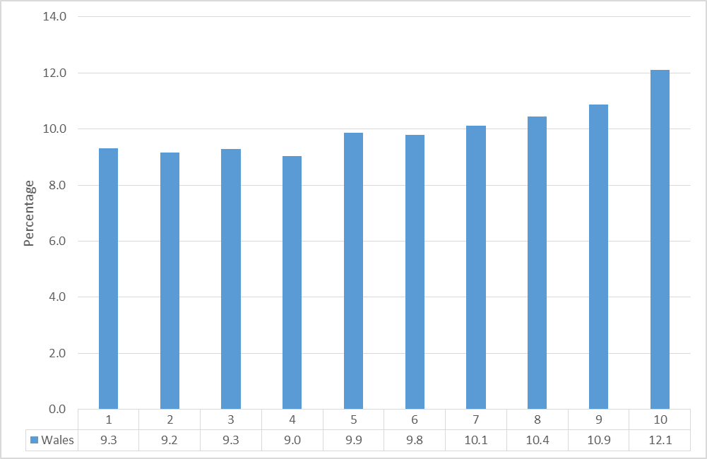

Figure 1.2 illustrates the distribution of the child population in Wales (0-17 years) by deprivation decile of the Welsh Index of Multiple Deprivation (WIMD). It would be reasonable to assume that 10% of the child population would live in each deprivation decile, however, Table 1.2 illustrates that this is not the case. The child population in Wales is under-represented in the least deprived deciles (1 – 6), but are over-represented in the most deprived deciles. This would fit with the findings of previous research (Townsend, 1979) that has highlighted that households with children are more likely to be living in poverty or on the edge of poverty.

### Figure 1.3 - Distribution of the Welsh child population by ethnic group and deprivation quintile

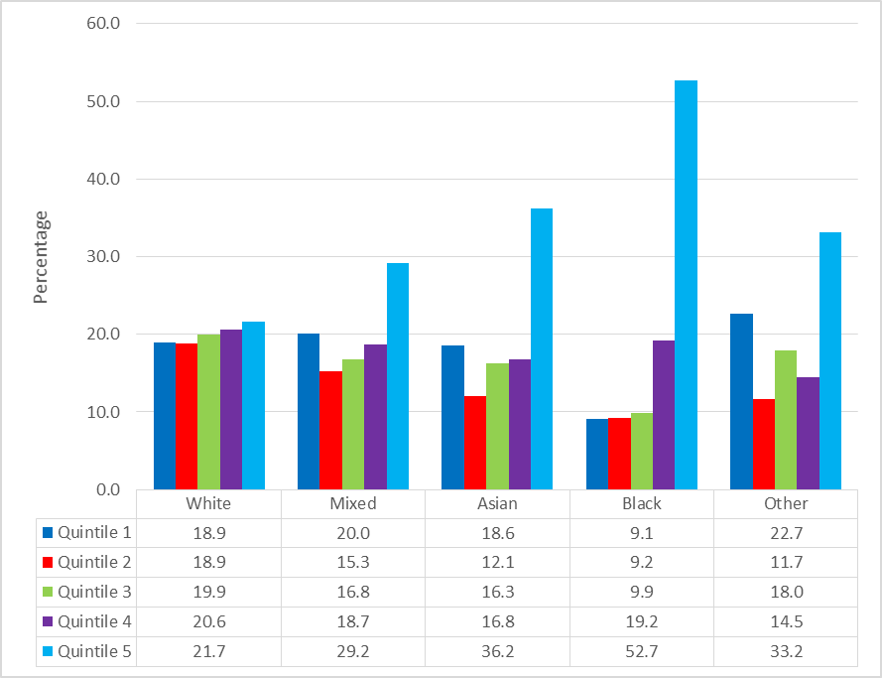

Figure 1.3 shows the distribution of children and young people within the Welsh child population based on four broad ethnicity groups. The data are drawn from the 2011 population Census. The table shows that broadly, White children are relatively evenly distributed between the five deprivation quintiles in Wales. In contrast, mixed background, Asian and Black children and young people are disproportionately represented in the 20% most deprived LSOA in Wales. This is particularly pronounced in relation to Black children, where over half live in neighbourhoods within the 20% most deprived in Wales

### Figure 1.4 - Distribution of Welsh child population, by age group and deprivation quintile

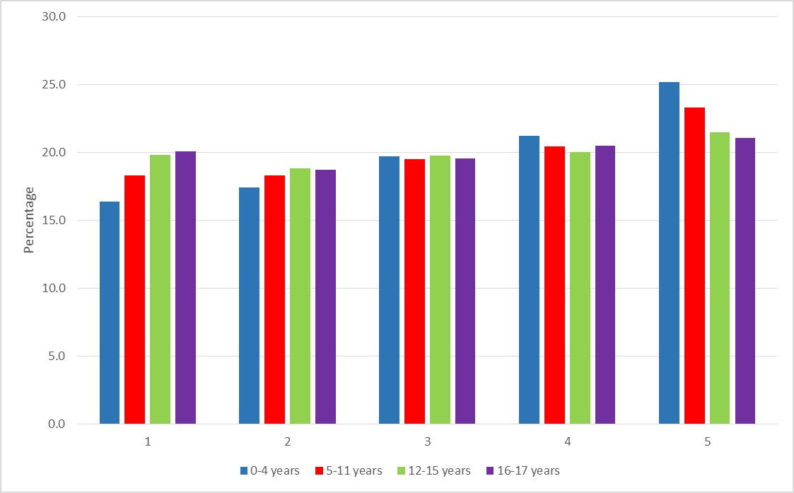

Figure 1.4 shows the distribution of the child population across deprivation quintiles by age group. The table shows that whilst in the middle quintiles (quintile 2, 3 and 4) the child population is broadly equally divided between the age groups, this is not the case in the least and most deprived quintiles. In the least deprived quintile (quintile 1) there are fewer young children, whilst in the most deprived quintile the opposite is true. The table shows that a quarter of young children (0-4 years) are living in neighbourhoods in the 20% most deprived in Wales

# 2. Area-Level Deprivation

### Figure 2.1 – Child protection and looked-after children rates (adjusted) by deprivation decile, Welsh Index of Multiple Deprivation, 2014

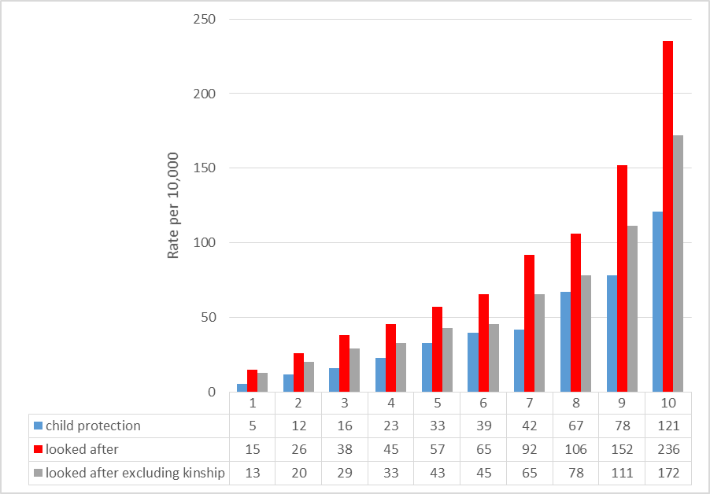

Figure 2.1 illustrates the overall rates per 10,000 for both children looked after and those on the child protection register (as at 31st March 2015) at the deprivation decile level. The graph clearly shows a ‘social gradient’ in terms of rates. Building on research on the social determinants of health, this term relates to the observable increase in rates per 10,000 for each increase in neighbourhood level deprivation. The steepest gradient is that for child protection registrations, where there is a 24-fold increase in rates between the least deprived decile (decile 1) and the most deprived (decile 10). The rates for all looked after children are almost 16 times higher in the most deprived neighbourhoods than in the least deprived. A similar gradient is observed for all looked after children other than those placed with parents, relatives or friends. There is a 13-fold increase in the rates of children looked after and living away from family and friends between the least deprived decile and the most deprived. The graph clearly illustrates the relationship between living in a poor neighbourhood and the likelihood of being the subject of local authority intervention, either by being subject to child protection procedures or becoming looked after.

Further analysis by the research team of data on all four UK nations, using a comparable measure of deprivation (Payne and Abel, 2012) shows that for both children looked after and for child protection, the social gradient in Wales is steepest of all four nations. That is, in Wales there are proportionally more children on child protection registers or taken into care in more deprived areas, and fewer in less deprived areas, than in the other nations. These results are not presented in the current report.

Spearman’s rank correlations were performed to assess the relationship between deprivation and different child welfare interventions. There is a strong statistically significant positive correlation between deprivation and child protection registrations [rs=1.0, p=<.001], overall rates of children looked after [rs= 1.0, p=<.001] and rates of looked after children excluding those placed with family and friends [rs= 1.0, p=<.001].

# 3. Gender

Figures 3.1, 3.2 and 3.3 show the rates per 10,000 by deprivation decile for boys and girls. For child protection registrations and all looked after children, rates for boys and girls are broadly similar. Although the rates by gender are also similar for children looked after who are not living with family and friends (Fig. 3.3), there are slightly more boys at all levels of deprivation and the difference is statistically significant. There was a significant main effect of deprivation decile on rates (F(1,16) = 675.49, p < .001), which were slightly higher in boys than girls (F(1,16) = 10.74, p = .005). The non-significant interaction term (F(1,16) = 2.27, p = .151) shows that this effect remained consistent across all deciles. The overall rates by gender in looked after children’s placements, excluding those placed with friends and family are 65 per 10,000 for boys and 57 per 10,000 for boys. The overall rates for child protection registrations (44 for boys, 46 for girls) and for all looked after children (87 for boys and 83 for girls) are much closer and vary more between deciles.

### Figure 3.1 Child protection registration rates (per 10,000) by gender and deprivation decile, Welsh Index of Multiple Deprivation, 2014

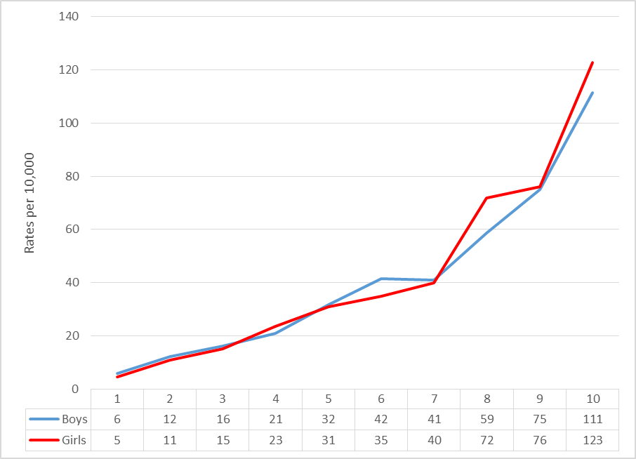

### Figure 3.2 Rates (per 10,000) of all looked-after children by gender and deprivation decile, Welsh Index of Multiple Deprivation, 2014

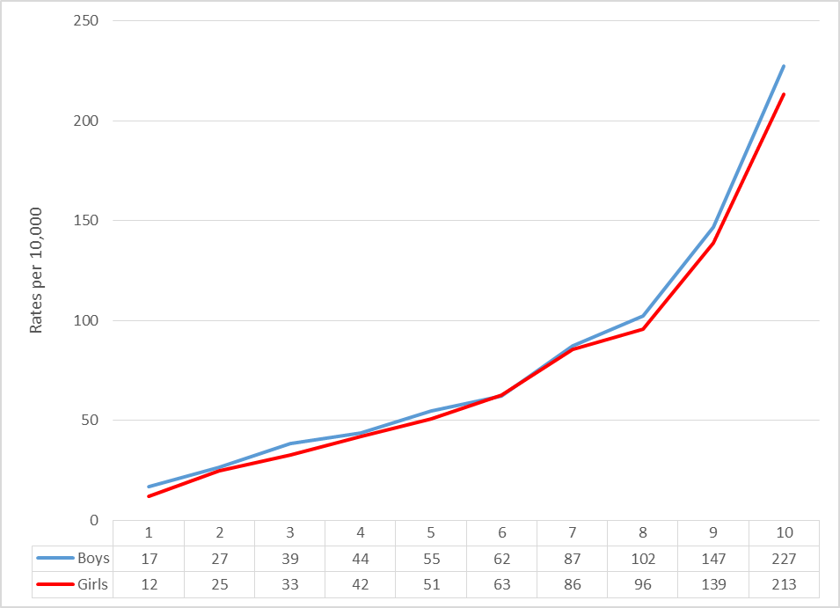

### Figure 3.3 Rates (per 10,000) of children looked after not placed with family or friends, by gender and deprivation decile, Welsh Index of Multiple Deprivation, 2014

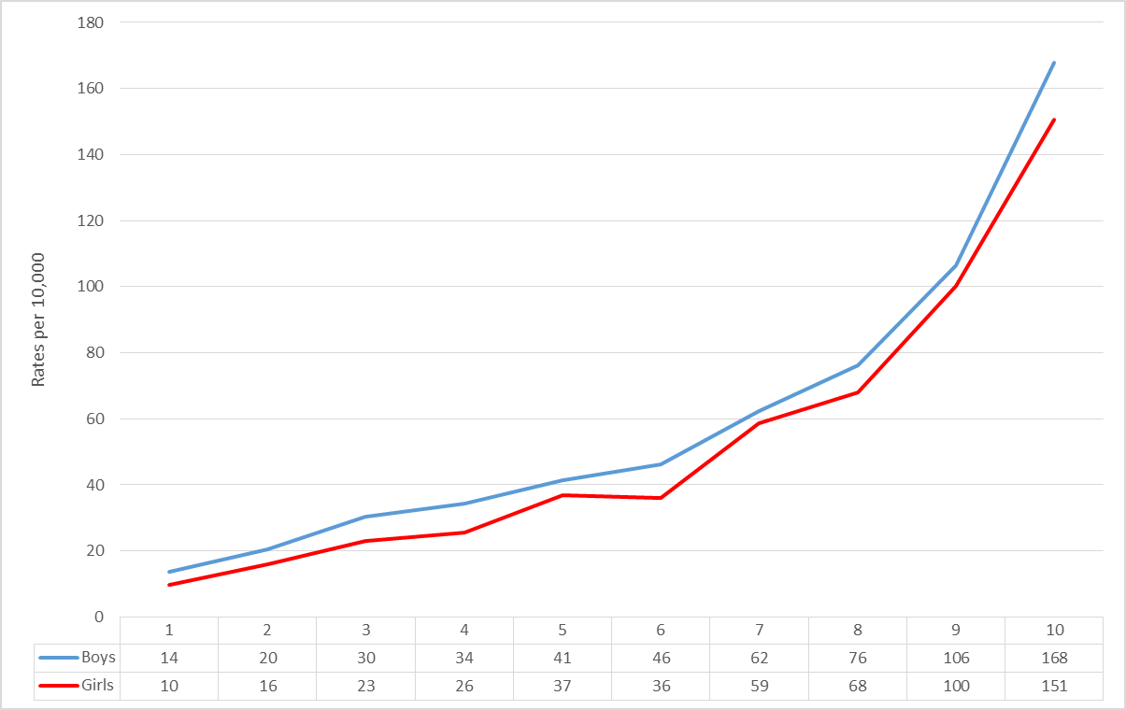

# 4. Age

The following tables show children on the protection register or looked after on the 31st March 2015 by age group (0-4 years, 5-11 years, 12-15 years and 16-17 years) and deprivation quintile.

### Figure 4.1 Child protection registrations by age group and deprivation quintile, Welsh Index of Multiple Deprivation, 2014

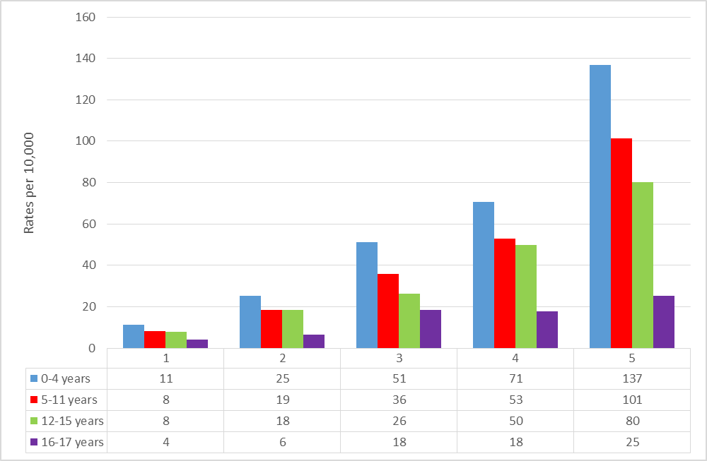

Figure 4.1 shows the rates for those children on the child protection register on the census day. The bar chart shows that at all deprivation quintiles the youngest age-group of children, i.e. those aged from birth to 4 years of age (the analysis does not include pre-birth registrations), are placed on the child protection register at higher rates than their older peers. Broadly the chart also shows that as age increases the rates of children being placed on the child protection register reduces, regardless of the level of neighbourhood deprivation.

Figure 4.2 shows the rates of children looked after by age group. The bar chart shows rates increasing as age increases across all deprivation levels. This finding would appear to not reflect the findings of other studies on the age profile of looked-after children e.g. Martin Elliott’s PhD research on Wales 2008-2014, which show higher rates of younger children, particularly those under 4 years of age. This would appear to be as a result of the data being ‘snapshot’ data relating only to the children in care on a particular day, rather than longitudinal data such as that used in other studies. There are more children aged 0-4 coming into care than shown in Figure 4.2 but many of these are only looked after for brief periods.

### Figure 4.2 all children looked after by age group and deprivation quintile, Welsh Index of Multiple Deprivation, 2014

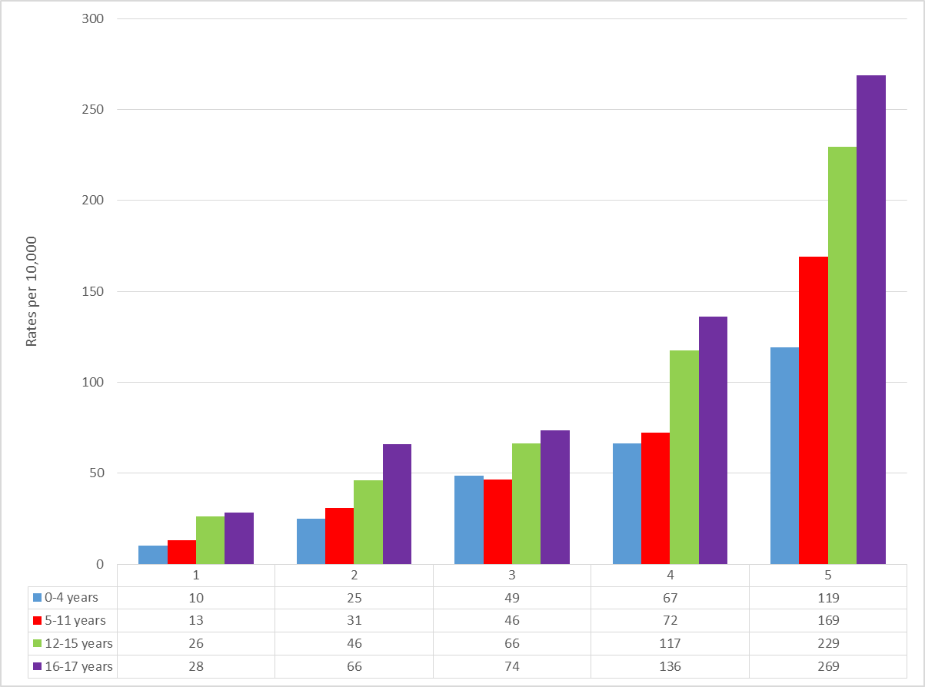

### Figure 4.3 Children looked after not placed with parents, relatives or friends, by age group and deprivation quintile, Welsh Index of Multiple Deprivation, 2014

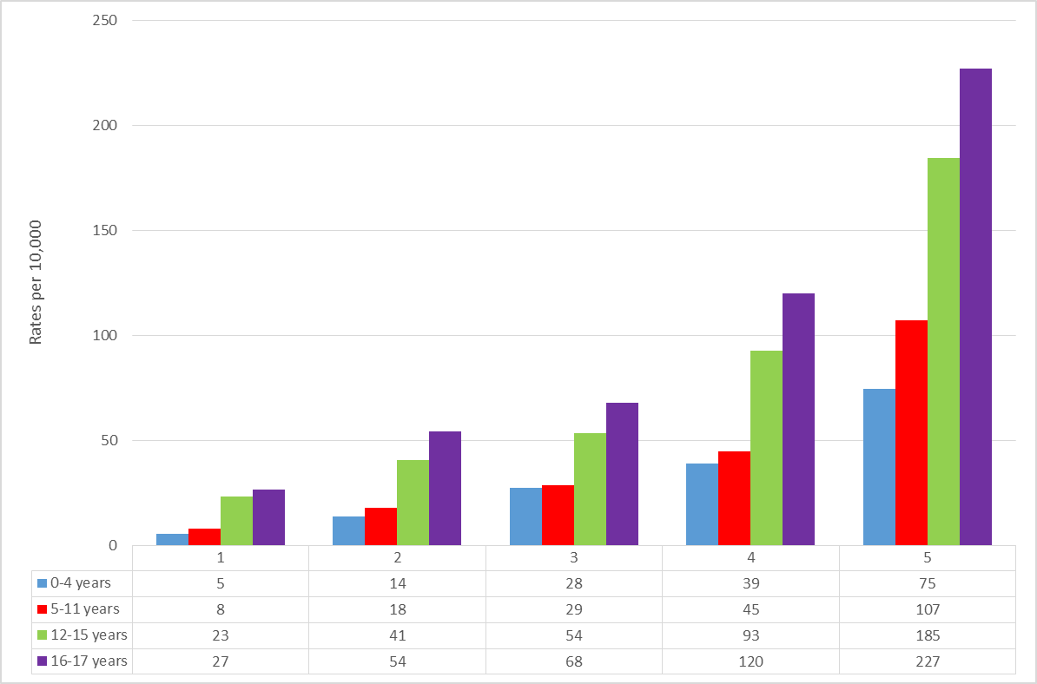

The age profiles of all children looked after on 31 March and those not placed with family or friends are similar, with the largest proportion at each level of deprivation being 16-17 year olds and the proportions by age group rising with increasing age. It is interesting to note the very different age distributions of child protection registrations and children looked-after.

# 5. Ethnicity

Tables 5.1 and 5.2 show the rates per 10,000 of children subject to an intervention by deprivation quintile and four broad ethnicity groups. The group ‘other’ within this part of the analysis includes those children where ethnicity is unknown or was not obtained.

### Table 5.1 Ethnic category by deprivation level for child protection



Column headings 1-5 represent quintiles (20% bands) of deprivation: 1=lowest quintile of deprivation and 5= highest

Table 5.1 shows that overall, mixed background children are placed on the child protection register at higher rates than children in the other three ethnicity categories, whilst Black and White children are subject to child protection procedures at broadly similar overall rates once differences in the size of the child population in each ethnic category are accounted for.

### Table 5.2 Ethnic category by deprivation level for all children looked after



Column headings 1-5 represent quintiles (20% bands) of deprivation: 1=lowest quintile of deprivation and 5= highest

Table 5.2 shows the rates per 10,000 for all looked-after children by deprivation quintile and ethnic group. As with child protection registrations the table shows that the overall rates of mixed background children in care on the 31st March 2015 were higher than those for the other three ethnic categories. Whilst for child protection registrations the rates for White and Black children were almost the same (41 and 42 per 10,000 respectively), in terms of being looked after, Black children are represented at higher rates than White children. It is also interesting to note that the highest rates of Black children in care are not from the most deprived neighbourhoods, as suggested by the overall figures illustrated in Figure 2.1, but are instead from the middle quintile (quintile 3). Black children also enter care at a higher rate from the least deprived quintile than they did from the most deprived, which is the reverse of all the other ethnicity categories used. Asian children are consistently less likely to be in care than children in the other ethnic categories, across all levels of deprivation.

# 6. Reason for being on the child protection register

This section of the report will look at the registration category of children on the child protection register. The analysis focuses of the four main abuse categories: Neglect, Physical Abuse, Sexual Abuse and Emotional Abuse. Figure 6.1 shows the percentage of children registered under these four categories broken down by deprivation quintile.

### Figure 6.1 Abuse category by deprivation quintile for child protection registration, Welsh Index of Deprivation, 2014

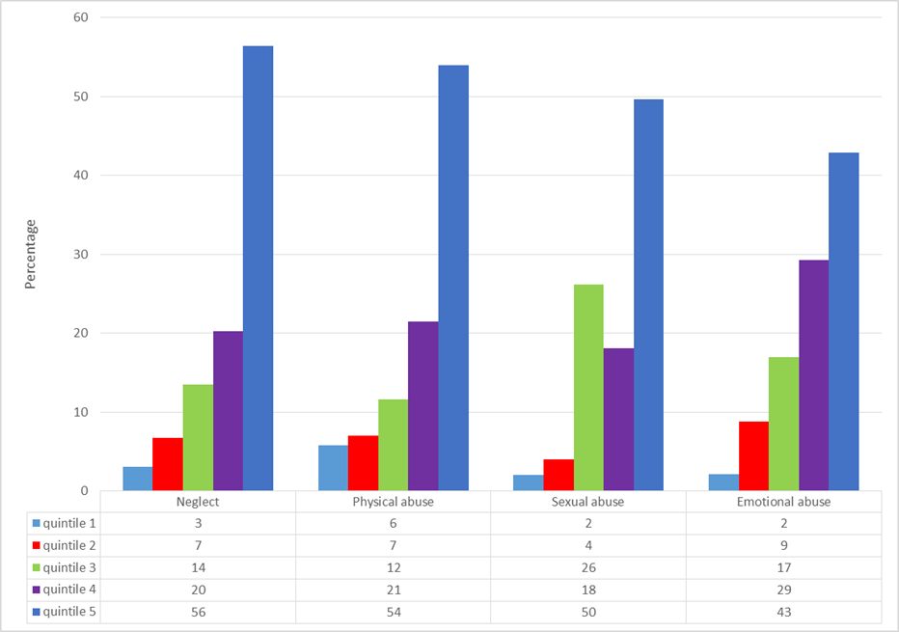

For the registration categories of Neglect, Physical Abuse and Emotional Abuse a clear ‘social gradient’ is visible in Figure 6.1. For each quintile increase in deprivation there is a corresponding increase in the percentage of children being placed on the child protection register under that category. The one category where the social gradient is less straightforward is sexual abuse, where there is a higher proportion of cases in quintile 3 than quintile 4. For sexual abuse, there is nonetheless a striking difference between the percentage of children being placed on the register in the most and least deprived areas. For children registered under this category there is a twenty five fold increase between the 20% most deprived neighbourhoods and the 20% least deprived, the largest variation in any of the abuse categories. Whilst those from the most deprived 20% of neighbourhoods (quintile 5) make up over half of those children registered under the categories of Neglect or Physical Abuse in the case of Emotional Abuse this is less, with higher percentages in some of the other quintiles than for other categories of maltreatment.

# 7. Legal Status of Children in Care

Figure 7.1 shows the legal basis under which children were in care on the 31st March 2015 by deprivation quintile. The legal status codes included in the SSDA903 return have been grouped into four categories. The four groupings used are:

* Child protection measures (Interim Care Order, Full Care Order, Police Protection, Emergency Protection Order, Child Assessment Order)
* Adoption (Freeing Order, Placement Order)
* Voluntary accommodation
* Youth justice (Remanded to the local authority, detained by the local authority under PACE, CYPA 1969 supervision order).

Due to small numbers, data on youth justice are not included in Figure 7.1 or Figure 7.2.

### Figure 7.1 – Legal status for all children looked-after, by deprivation quintile, Welsh Index of Multiple Deprivation 2014

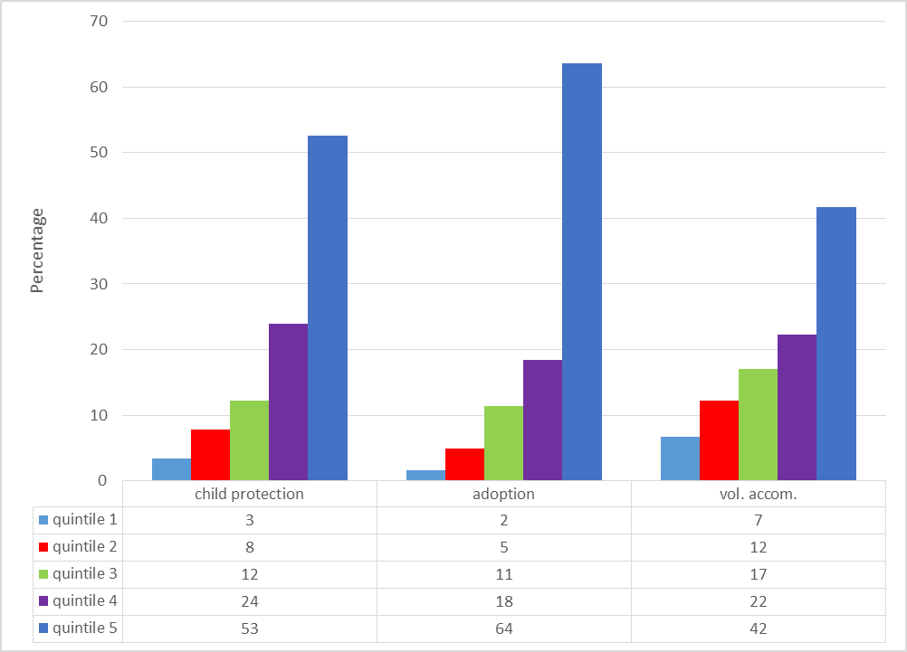

As highlighted when considering the overall rates, there is an observable ‘social gradient’ in the rates of children looked after on the basis of all the groups of legal status used. As neighbourhood level deprivation increases, so does the percentage of children in care under each legal category.

Young people who are in care on the basis of involvement with the Youth Justice system are drawn from the two most deprived quintiles only.

In terms of those whose legal status is that they are on an adoption Placement Order (or in a small number of historical cases on a Freeing Order) over 60% of these children lived in neighbourhoods in the 20% most deprived in Wales before entering care

### Figure 7.2 – Legal status for children looked after, excluding those placed with parents, relatives and friends by deprivation quintile, Welsh Index of Multiple Deprivation, 2014

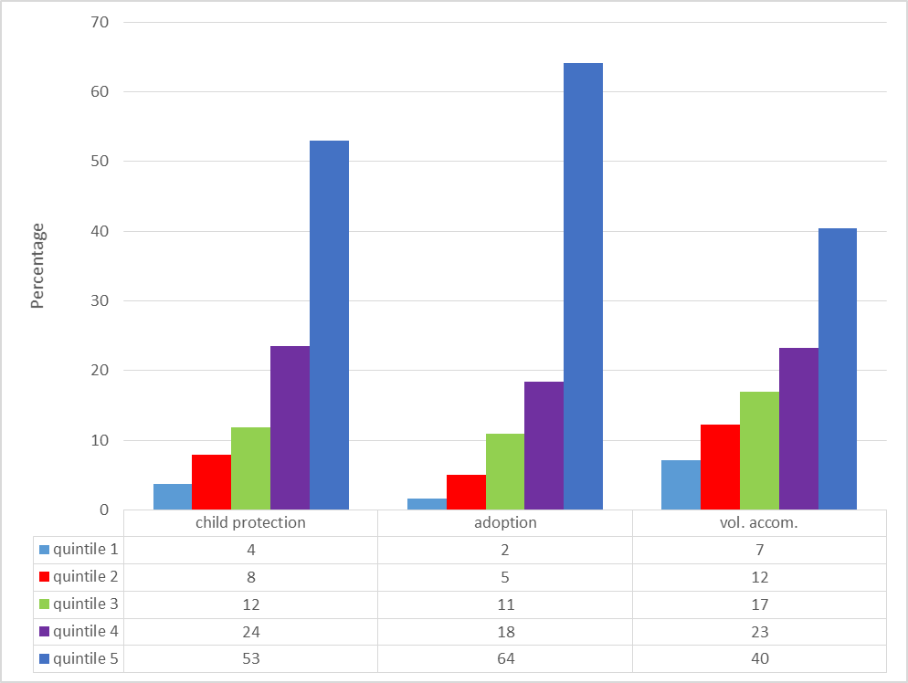

Figure 7.2 shows the percentage of children looked after by legal status and deprivation quintile for all children looked after excluding those placed with parents, friends or relatives. The legal status groupings are those used for outlined for Figure 7.1. Comparison of these two figures suggests that exclusion of these placement types makes no observable difference to the overall composition of each legal grouping at the quintile level.

# 8. Inverse Intervention Law

For these analyses the local authorities included in each sample were divided in to three comparison groups based on their overall deprivation score. The aim was to replicate the analysis by Bywaters *et al*. (2016), which found that although overall local authority rates of child welfare interventions were correlated with deprivation at an LA level, where LSOAs were compared between LAs, at each decile of deprivation intervention rates were higher in LAs that were less deprived after all. They labelled this the ‘inverse intervention law’, echoing Tudor-Hart’s (1971) inverse care law in health care.

### Figure 8.1 –Child Protection rates in local authorities divided into three deprivation bands (high, medium, low) by deprivation decile.

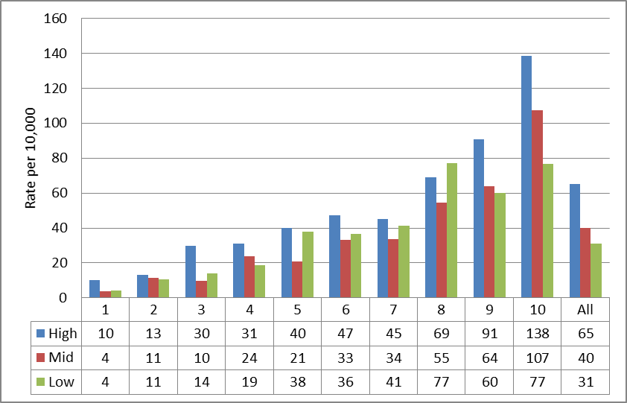

Figure 8.1 shows a comparison by deprivation decile of the rates per 10,000 within each of the three comparison groups of local authorities. What the graph shows at the 8th decile is an example of the Inverse Intervention Law (IIL). Whilst we showed in Section 2 that the largest proportion of children who experience contact with child protection are drawn from the most deprived neighbourhoods at this decile, it is the group of local authorities with the lowest levels of overall deprivation that have intervened at a higher rate. At all other deciles, although there are some variations in rates in the groups of low and mid-level deprivation authorities, it is those authorities with the highest levels of deprivation that intervene more.

In comparison to the child protection rates in Figure 8.1, Figure 8.2 which illustrates the same analysis for all looked after children, shows a number of examples of the Inverse Intervention Law at deciles 5, 6, 8 and 10. Decile 10, the 10% most deprived neighbourhoods in Wales can be used to discuss what the data are showing. Overall, local authorities in the group of local authorities with the lowest levels of deprivation (Low) would have the fewest of these neighbourhoods, whilst those with the highest levels of deprivation (High) would have the most. However, if a rate is calculated only using the child population living in the neighbourhoods that fall within that decile in each of the comparison groups, it is the less deprived group of local authorities which intervene at a higher rate. Unlike in Bywaters *et al*.’s analysis of English data, however, the pattern is not consistent in Wales and the differences between the rates for the three comparison groups of LAs at any given level of deprivation are not statistically significant. We therefore conclude this analysis does not show any evidence of an overall inverse intervention effect in Wales, for either child protection or children looked after.

### Figure 8.2 – Rates of children looked after in local authorities divided into three deprivation bands (high, medium, low) by deprivation decile.

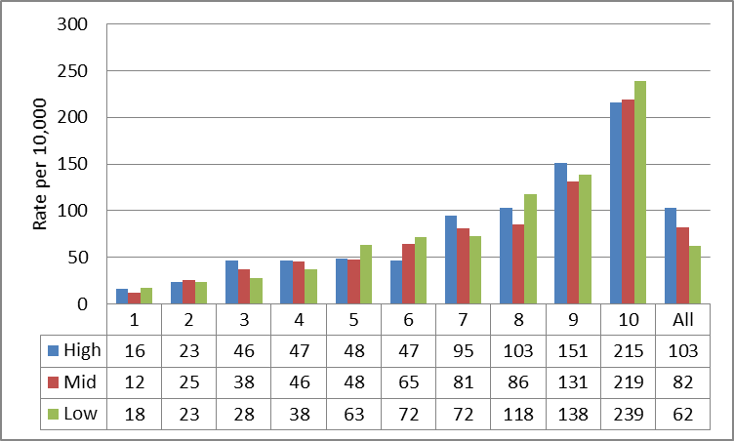

# 9. Spend

Using publicly-available information from Stats Wales on spending on Children’s Services in Wales (all Children’s Services), we calculated the difference in spend per head of child population between the 2010-11 financial year and 2014-15, to assess the difference that austerity policies may have made. This was done for each of three groups of local authorities, low deprivation, medium deprivation and high deprivation, based on population-adjusted local authority level deprivations scores from the Welsh Index of Multiple Deprivation. This calculation revealed that spending increased with increasing levels of deprivation. This would be expected, as the Index of Multiple Deprivation informs Welsh Government decisions about the allocation of budgets to local authorities. The calculation also showed that spending per head of child population had in fact increased between 2010-11 and 2014-15 (see Figure 9.1), whereas in England the opposite is true (Figure 9.2). Part of the reason for this is that the child population in Wales decreased between these two time points whereas it increased in England. Another reason would be political commitment to maintain spending on social care.

### Figure 9.1 Total spend per child on Children’s Services in Wales, by local authority deprivation level, comparing 2010-11 with 2014-15

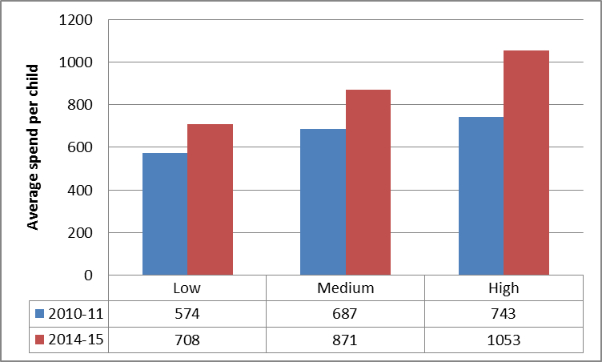

### Figure 9.2 Total spend per child on Children’s Services in England, by local authority deprivation level, comparing 2010-11 with 2014-15

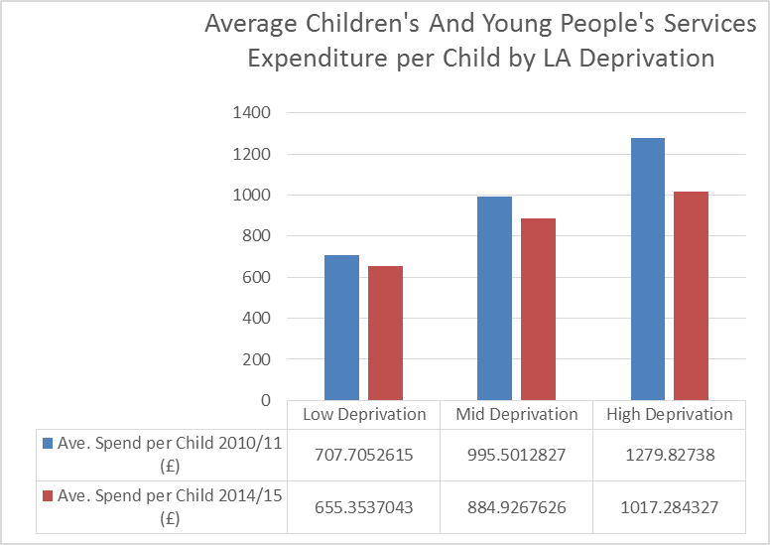

The average percentages of total net revenue spend on Children’s Services that was allocated to looked after children services was 42.3% in 2010/11 and 44.8% in 2014/15, showing a small increased percentage, in the context of increasing overall spend.

# 10. Discussion and conclusion

Overall, the results show a very strong relationship between rates of child protection / children in care in Wales and deprivation in local areas. Similar patterns are seen across levels of deprivation for different age groups, for boys and girls, for legal status and for the reasons given for child protection registration. There are also inequalities between ethnic groups, with mixed-race children most likely to come into care and Asian children least likely.

Here are some of the policy and practice implications:

***Child welfare inequalities should be a political priority***

Although we often hear about the need to tackle inequalities in health and education, and the Welsh Government is working hard in these areas, child welfare inequalities are rarely considered. Given the disparity in intervention rates between more deprived and more affluent areas and the variation by ethnic category, child welfare inequalities need to be a similarly high priority.

***Putting child protection on the child poverty agenda***

In policy and practice, child protection and reducing child poverty tend to be separate domains. There are some understandable reasons for this – it is important to avoid any suggestion that all children in poor families are at risk of abuse. However, poverty is a crucial part of the context in which much child abuse and neglect takes place and large-scale prevention of harm to children is unlikely to be successful without attention to poverty.

***Putting poverty on the adverse childhood experiences agenda***

Adverse childhood experiences (ACEs) have recently become a policy focus in Wales. This is to be welcomed, given their strong association with poor health outcomes in adulthood. The evidence base shows that ACEs have an effect over and above the experience of poverty. However, the social problems which cause ACEs are heavily concentrated in the most deprived areas. Poverty therefore needs to be on the ACE agenda in Wales and not separate from it.

***Linking up poverty reduction and social services***

It has become rather taken for granted that the work of children’s social services takes place largely in the poorest communities. The evidence presented in this report tells us that poverty reduction needs to be at the heart of social work intervention and not at the margins. In many families with deep-rooted problems, improving family incomes may not be sufficient to remove risk to children. However, it should be *part* of the help provided. Regional partnership boards need to consider how social services can contribute to poverty reduction.

***Better data, more research***

We also need better data and more research. We need to know more from routine administrative data about the circumstances of individual families, including their socio-economic status. We also need postcode data routinely included in the children in need census so that researchers can continue to monitor child welfare inequalities at an area level. Most importantly, we need to know more about outcomes for children following state interventions and whether putting children in care improves their life chances.

# References

Bywaters, P., Brady, G., Sparks, T., and Bos, E. 2016. Child welfare inequalities: new evidence, further questions. *Child & Family Social Work*, 21: 369–380. doi: 10.1111/cfs.12154.

Payne, R.A. and Abel, G.A. 2012. UK indices of multiple deprivation – a way to make comparisons across constituent countries easier. *Health Statistics Quarterly. 53. pp.1-16*

Townsend, P. 1979. *Poverty in the United Kingdom: A survey of household resources and standards of living*. Berkeley: University of California Press

Tudor Hart, J. 1971. The inverse care law. *The Lancet. Saturday 2th February 1971. pp.405 - 412*