



**Newton Mobility Grants**

**Isihloko seprojekthi: “Ukwakha uphando olusekelwe kwindlela ye-*action research* ukuzama ukuqonda amaziko akule ngingqi angabanegalelo kufuyo nokuphucula ubomi ngokusekelwe emfuyweni kumafama emfuyo asakhasayo eMpuma Koloni eMzantsi Afrika.”**

**Ingxelo yewekshophu ebibanjwe ngomhla we-13 ukuya kwi-15th September 2016, eSinako Guest House, eCala, kwiPhondo leMpuma Koloni eMzantsi Afrika.**

**Dr James Bennett,**

**Centre for Agroecology, Water and Resilience, Coventry University,**

**British Academy-Newton Mobility Grants**

Ingxelo yewekshophu ebibanjwe ngomhla we-13 ukuya kwi-15th September 2016, eSinako Guest House, eCala, kwiPhondo leMpuma Koloni eMzantsi Afrika.

Le wekshophu ibisesinye seziphumo eziphambili ezilindelekileyo kule projekthi. Eyona njongo iphambili yale wekshophu ibi: *kukuzama ukuqonda imiqobo ekuhanjisweni kweeprojekthi ezingqamane nemfuyo eMpuma Koloni nokuba ingaba iindlela ze-**action research zinganakho na ukuphucula ukubandakanyeka koluntu nasekuphumeleliseni iiprojekthi ezenziwayo*. I-*action research* luhlobo lophando-nzulu apho abantu bathatha inxaxheba ekusombululeni iingxaki zabo ukuze badale utshintso abalufunayo.

Ukuphumeza le njongo, abaphandi bayenze iwekshophu yagxile kuphela kuhlobo leefandesi ezinongenelelo loncedo oluqhutywa ngurhulumente ekuthiwa xa zibizwa yi-“*custom feeding program*”, bamema noluntu olubandakanyekayo oluphuma kwizithili ezintathu apho seziqalile khona ezi fandesi ukuze luthathe inxaxheba. Eneneni, le wekshophu ibeliqonga lokuvakalisa iimfuno zophuhliso ngokubanzi, yanikeza nethuba lokunika ingxelo ephuma kwiiprojekthi ezenza uphando-nzulu ngophuhliso lemfuyo ebeziqhubeka kwiilali ezimbini. Le ngxelo ishwankathelweyo iveza imiba ephambili ephakanyiswe ngabameli boluntu, ze kuyo kudityaniswe uludwe lamanqaku avela eluntwini ekunokunyathelwa kuwo ukuphucula ukubandakanyeka kumaphulo eefandesi nasekuhanjisweni kweenzuzo zoko kwabo babandakanyekayo nabachaphazelekayo.

**Ababandakanyekayo bayahlangana**

Kuqale kwaba neengxoxo ezinde malunga nokuba ngobani abamele ukubandakanyeka kwiwekshophu. Njengoko enye yeenjongo eziphambili ibikukuzama ukufumana izimvo ngeyona ndlela amafama azibona ngayo iifandesi, isidingo sokunika ‘indawo ekhuselekileyo’ apho amafama angazondlala ngokukhululekileyo izimvo zawo engenaloyiko lokuba angabekwa izisolo bekubalulekile ukuyiqwalasela. Esi ibisisiseko esingundoqo ekufunyanweni kwesivumelwano sokusebenzisana ngentlonipho (*ethical approval*) sokuqhuba le projekthi e-Coventry University (Project No. P45588), kwaye oku kuye kwacaciswa kubathathi-nxaxheba kwasekuqaleni kwewekshophu. Abaphandi-nzulu babone ngathi nangona bekuzakuba luncedo ekwandiseni ukuqonda ngemiqobo eyenziwa yipolitiki ekuhanjisweni kweeprojekthi ukumema abameli abasuka kumaqumrhu karhulumente anoxanduva lokuhambisa iinkonzo, bekunowanciphisa amathuba okuba amafama athethe ngokukhululekileyo ngendlela eziqhuba ngayo iiprojekthi, oku kube nomthelela kwiimeko isivumelwano esinikwe phantsi kwazo. Isigqibo sathathwa sokuba abameli bemibutho ephambili efana ne-National Agricultural Marketing Council (NAMC), (iyiyeyona inoxanduva lokujongana neefandesi kwezi lali) baziswe ukuba iwekshophu iyaqhubeka kodwa hayi ukuba beze. Kwavunyelwana ukuba bazokwaziswa ngendlela ehambe ngayo iwekshophu neziphumo zayo ngokunikwa le ngxelo. Kwaye kwavunyelwana kwakhona ukuba ingxelo izakuguqulelwa esiXhoseni ukulungiselela uluntu olubandakanyekayo oluntetho isisiXhosa.

*Abathathi-nxaxheba*

Abathathi-nxaxheba bebequka: -

Dr James Bennett, Coventry University (CU), (Umphandi)

Dr Colin Anderson (CU)

Mnu Lovemore Gwiriri (CU)

Mnu David Neufeld (Umcebisi Ozimeleyo osuka e-Canada)

Dr Cletos Mapiye, Stellenbosch University (SU), (uMphandi Oyintloko)

Mnu Tawanda Marandure (SU)

Nkszn Vuyo Bangani (SU)

Bekukho nabathathi-nxaxheba abamagama angakhankanywanga abasuka kwezi zithili zintathu zilandelayo:

*Ifandesi yaseNchora*

Amafama emfuyo amabini, ababini abalulutsha, nomfundi osandula ukugqiba izifundo osaqeqeshelwa umsebenzi (i-*intern*) (abathathi-nxaxheba aba-5);

*Ifandesi yakuGxwalubomvu*

Bekungekho mafama, ibingabahlanu abalulutsha, nomfundi osandula ukugqiba izifundo osaqeqeshelwa umsebenzi (abathathi-nxaxheba aba-6);

*Ifandesi i-IKephu* (ifandesi yamafama agqibeleleyo)

Amafama emfuyo amabini, umanejala wefandesi, abafundi ababini abasandula ukugqiba izifundo abasaqeqeshelwa umsebenzi (abathathi-nxaxheba aba-5);

Ngokungalindelekanga, ingxenye enkulu yabathathi-nxaxheba abasuka kwiifandesi ibingamagosa ajongene nolawulo leefandesi lemihla ngemihla, ingengawo amafama oqobo. Izizathu zokungazibandakanyi kwamafama negalelo oku ekunganalo kwiziphumo icacisiwe ekupheleni kwale ngxelo.

**Indlela elungiselelwe ukuba iqhutywe ngayo iwekshophu**

Iwekshophu ithathe iintsuku ezintathu. Ibihlelwe ngohlobo lokuba izamkele ngokulinganayo zonke iingcinga nezimvo zabo bonke abebekhona. Oku kuye kwafuna utshintsho kwindlela yokuqala ebekujongwe ukuba kuzakusetyenzwa ngayo neendawo ezithile kwindlela ebizokusetyenziswa. Into ekuqalwe ngayo ibe kukubeka imithetho yokuba izakuqhutywa njani iwekshophu ukuqinisekisa ukuba bonke abathathi-nxaxheba baziva bekhululekile. Ikhawuleze yacaca eyokuba abathathi-nxaxheba abaninzi abaziva bekhululekile ngoluvo lokuthatha imiboniso bashicilelwe bethetha ngezinto ezenzekayo ezinganobuzaza. Ukusebenzisa imiboniso ibiyenye yezona ndlela abaphandi-nzulu ebebejonge ukuthatha ngayo iziphumo zewekshophu, ngokwenza amaqela ohlukeneyo athathane imiboniso exoxa ngeminye yemiba ephambili. Isigqibo saye senziwa ekuqaleni kwewekshophu ngabo bonke ababekhona ukuba kusetyenziswe kuphela ezi ntlobo zintathu zokuqokelela ulwazi: kubhalwe phantsi konke okuthethwayo, amaphepha amakhulu axhonywa ebhodini (*flipcharts*) kunye neefoto kuphela.

Iintsuku ezimbini zokuqala zigxile ekuphumezeni ezona njongo zeprojekthi ngokwakwisiphakamiso seprojekthi. Isigqibo sokungena kusuku lesithathu sithathwe ekuqaleni kwewekshophu ngokwesidingo esaboniswa ngabathathi-nxaxheba ababekhona. Olu suku lusetyenziswe njengesiseko sokunika ingxelo ngeziphumo zethutyana zophando-nzulu oluqhubekayo kwezi lali ukuze noluntu lulubeke phambili uphando-nzulu oluqhubekayo, iimfuno zoqeqesho nophuhliso. Usuku ngalunye nomsebenzi ngamnye ubukhokelwa ngomnye wabakwiqela labaphandi, uthethwano phakathi kweqela labaphandi nabathathi-nxaxheba belusenziwa ngesiNgesi ze liguqulelwe esiXhoseni. Xa besenza umsebenzi abawunikiweyo, abathathi-nxaxheba bebehlulwa ngokweefandesi abasuka kuzo ze bafumane ithuba lokunxibelelana nabathathi-nxaxheba abasuka kwezinye iifandesi ngexesha lesidlo sasemini, xa kunikwa ingxelo, nangexesha abengenzi nto ngalo ngaphambi okanye emva kweengxoxo ebezihleliwe zosuku. Iingxoxo beziqhutywa nangaluphina ulwimi abathathi-nxaxheba abakhululeke ngalo, kodwa ingxelo ngeziphumo ezingohlobo lentetho nezibhaliweyo bezisenziwa ngesiNgesi ze ingxelo engohlobo lentetho iguqulelwe esiXhoseni. Umgaqo olandelweyo ubungoluhlobo: -

*Usuku lokuqala*

Kusasa: Ukwazisana phakathi kweqela lophando nabathathi-nxaxheba boluntu, kwaziswe kucaciswe nezona njongo zewekshophu. Kunikwa intetho ngendlela ezakuqhutywa ngayo iwekshophu ukuze kuqinisekiswe ukuba abathathi-nxaxheba bakhululekile ngoko, kugcwaliswe kutyikitywe nesivumelwano sokusebenzisana ngentlonipho ngabo bonke ababandakanyekayo.

Emini: Abathathi-nxaxheba bohlulwe bangamaqela amathathu ngokweefandesi abasuka kuzo, bacelwa ukuba baxoxe banike nentetho ngeyona miba enxulumene nendlela ezisebenza ngazo ezi fandesi. Njengesikhokelo, bacelwe ukuba baqwalasele imiba engezopolitiko, amaziko, ubugcisa okanye ubuchwephesha kunye neziseko.

*Usuku lesibini*

Kusasa: Abathathi-nxaxheba bazikisa ukucinga ngabakwenzileyo kusuku olungaphambili nabakufundileyo. Kwenziwa uhlalutyo leefandesi kusetyenziswa i-*SWOT analysis*, okuthetha ukuba kujongwa amandla (*strengths*), ubuthathaka (*weaknesses*), amathuba (*opportunities*) neenkxalabo (*threats*) ukuqikelela ikamva leefandesi. Iziphumo zolu hlalutyo babelene ngazo ngentetho eyenziwe liqela ngalinye besebenzisa amaphepha amakhulu ebebebhale kuwo bawaxhoma ezibhodini (*flipcharts*).

Emini: Banikwa umsebenzi wokwenza izicwangciso zokuphuhlisa ikamva leefandesi ngokuhlalutya unxibelelwano abanalo nawo onke amaqumrhu achaphazelekayo nabandakanyekayo kula mahlelo eefandesi. Abathathi-nxaxheba kwifandesi nganye bacelwe ukuba benze imizobo eshwankathela unxibelelwano phakathi kwabo namaqumrhu ayanyaniswa nokuphuhliswa kweefandesi, ubude bomgama abawubonisayo kwimizobo ubonisa ukuqina kobudlelwane, (amaqumrhu abekwe asondela kwifandesi abonisa ukuqina ze lawo abekelwe kude abonise ubuyekeyeke bobudlelwane). Bacelwe nokuba babhale uludwe lamanye amaqumrhu abangabanomdla wokwakha ubuhlobo nawo ekuhambeni kwexesha. Ngokusekelwe kulo msebenzi nemiba eqapheleke xa bebesenza uhlalutyo leefandesi ngokujonga amandla, ubuthathaka, amathuba neenkxalabo, kuye kwabakho ingxoxo, kwanikwa nentetho ngezisombululo ezingabakhona ukucombulula eminye yemiba kwanabadlali abangaba ngabaphambili ekuzameni ukuphumeza oku. Amaqela abuyele ekujongeni nasekuhlalutyeni imizobo ebeyenzile ukubonisa ukuba lungaphunyezwa njani olunye utshintsho ebebecinga ukulenza – ngokufakela abadlali abatsha nangokulungisa ubudlelwane nabo sebenobudlelwane nabo.

*Usuku lesithathu*

Kusasa: U-Dr Cletos Mapiye noMnu. Tawanda Marandure abasuka e-Stellenbosch University banike intetho ngeziphumo zophando zeeprojekthi ezingqamene nemfuyo abazenza ezilalini. Kuqwalaselwa izidingo zoluntu ezingoqeqesho, uphando nophuhliso nezinokuthi zisonjululwe ngobambiswano phakathi korhulumente neStellenbosch University.

Emini: Kuvalwa iwekshophu ngokusesikweni. Ithuba lokuba abameli abasuka kwiifandesi zamafama asakhasayo bandwendwele ifandesi yamafama agqibeleleyo - Ikhephu.

**Iziphumo zewekshophu**

Kule ngxelo akukho zinzame zokushwankathela intetho nengxoxo ezenziwe ngemini yesithathu yewekshophu ekubhalwe ngazo. Intetho eyenziwe ngabaphandi abasuka eStellenbosch University beyenzela abathathi-nxaxheba iyafumaneka kushicilelo olwenziwe ngemiboniso i-*Powerpoint* elifumaneka kweli khasi leprojekthi: <http://www.coventry.ac.uk/research/research-directories/current-projects/2017/developing-an-action-research-based-approach-for-understanding-local-institutions-and-improving-livestock-based-livelihoods-of-communal-farmers-in-eastern-cape-province-south-africa/> Ezona ziphumo ekubhalwe ngazo apha zezo kuphela ebezenzeke ngeentsuku zokuqala ezimbini zewekshophu kwaye zihlelwe ngokwemisebenzi eyenziweyo.

*Kuqatshelwa imiqobo ekusebenzeni kweefandesi*

Ubuchwephesha/iziseko

*Iifandesi zamafama asakhasayo*: Ulwazi olunqongopheleyo ngofuyo kumagosa abekelwe ukuba axhase ezi fandesi. Umzekelo, zinqunyulwa iimpondo xa zibudala bungakanani iinkomo ukuze zikulungele ukungena efandesini? Amanye amagosa kwifandesi zamafama asakhasayo awazami nokuzama ukunqumla iimpondo zeenkomo ngenxa yokungazi ukuba zinqunyulwa njani. Kwakhona, abanalwazi lokuba kokuphi okona kutya kuzilungeleyo iinkomo ezisefandesini. Kananjalo abahlali abakwiingingqi apho kukho iifandesi zamafama asakhasayo abanalwazi laneleyo ngokubaluleka kweefandesi kwindima yokwandisa ixabiso leenkomo ezisencinci ngokuzityebisa ukuze zibe nobunzima / isisindo esifanelekileyo xa zithengiswa. Iinkomo kufuneka ziziswe efandesini xa zinobunzima obuqikelelwa ku 180-200 kgs, zibudala buziinyanga ezili-9 ukuya kwi-12. Ukusuka apho, abanini mfuyo abaninzi bazisa iinkomo ezindala ezingazuzisa xabiso laneleyo, okanye xa kukho imbalela ukutya kwemfuyo kunqongophele. Ngokwenyani, bazisebenzisa ezi fandesi ukugcina iinkomo ezindala nezisengciphekweni kokuphila.

*Kwifandesi yamafama agqibeleleyo i-Ikhephu*: Abanini- mfuyo bazizisa iinkomo zisencinci kakhulu, oku kwenza inkcitho ekutyeni njengoko kufuneka zondliwe zikhule de zifikelele kubunzima obufanelekileyo. Ukuziswa kwezikali zokukala ubunzima kube luncedo ekunciphiseni le ngxaki, ngoku iinkomo ziba zikulungele ukuxhelwa kwisithuba seenyanga ezi-4 ukuya kwezi-5. Oomatshini bokunqumla iimpondo nabokuthena imfuyo abanelanga. Ukunqaba kwamanzi kuyingxaki kule fandesi.

Amaziko

*Iifandesi zamafama asakhasayo*: Zombini ezi fandesi zikhankanye ukuba inkxaso kunyango lemfuyo luduru kwaye inqongophele amaxesha amanininzi. Kufuneka kubekho ugxininiso kuqeqesho, ekwakhiweni kwezakhono nasekuqulunqweni kwemibutho nonxibelelwano lokwabelana ngolwazi. Enye ingxaki ingokutya kwemfuyo, ngamanye amaxesha kufika kade. Oku kubangela ukungabikho kokutya de abantu banyanzeleke ukuba basebenzise imali yombutho ukukuthenga. Iintlobo ezithile zokutya ngamanye amaxesha zibakumgangatho ophantsi nobangela ukuqunjelwa kweenkomo, ingakumbi xa kunengca encinci. Abasebenzi bezifandesi banamaxesha ongawufumani umrholo wabo kurhulumente.

*Ikhephu*: Inkxaso yonyango lemfuyo inqongophele – amaxesha amaninzi oogqirha bemfuyo ababinazimoto ezinokubenza bafikelele kwiifandesi. Amagosa ayabhatalisa ngokundwendwela iifandesi zamafama agqibeleleyo kwaye oku kuba ngaphezulu kokufikelelekayo epokothweni yamafama amaxesha amaninzi

Ezoqoqosho

*Iifandesi zamafama asakhasayo ne-Ikephu:* Kuneendidi ezimbini zokuthengisa, imarike esemthethweni (*formal market*) nemarike engekho semthethweni (*informal market*) kodwa abantu abanaqhinga laneleyo lokusebenzisa ezimarike ukuze zibasebenzele ngokufanelekileyo. Kwimarike esemthethweni bathengisa esilarheni, ixabiso lihamba ngokobunzima benkomo – ukuba isisindo sincinci akubikho nzuzo. Kwimarike engekho semthethweni bathengisela uluntu kwalapha ekuhlaleni xa kunemisebenzi yesintu, inzuzo ithe xhaxhe – amaxesha amaninzi malunga ne- R1500 ngaphezulu kunentengiso yasesilarheni. Kodwa ushishino kolu hlobo lemarike luyacotha kwaye lubakho ngamaxesha athile enyakeni kuphela. Eyona nto yenza kube lula ukusebenza nesilarha kukuba maxa wambi bathatha zonke iinkomo ezithengiswayo ngaxeshanye kwaye bathenga maxa onke enyakeni.

Ezopolitiko

*Iifandesi zamafama asakhasayo:* Iingxaki zenzeka kumazinga amabini. Kwiipolitiki zelizwe, kwesinye sezithili apho kunefandesi khona bekonyulwe uceba ongenalwazi ngezi fandesi ngoku akanamdla wokunceda abaxhase ngokwempembelelo anayo kwezopolitiko. Ekuhlaleni, kunokumonelana okuphembelelwa zezi fandesi. Umzekelo, abantu abangengomalungu ombutho weefandesi bazisa iinkomo zabo ngobusuku ngaphandle kwemvume ukuze zitye efandesini kuba bakholelwa ukuba ifandesi yekarhulumente ngokoke wonke umntu unelungelo lokuxhamla. Amanye amalungu oluntu afuna ukuqala imibutho yamafama kodwa abanye bakholelwa ekuzimeleni – imibono eyahlukileyo.

*Ikephu*: Abanye oosopolitiki bayayinyhasha imithetho yeefandesi ukuze imfuyo yabo izuze. Amanye amafama anokungoneliseki, abanye banomona kangangokuba bakhuthaza abantu ukuba bangazisebenzisi ezi fandesi. Ukungavisisani phakathi kwamafama kwenziwa kukungafikeleleki kwezixhobo zokusebenza kuwonke-wonke, umzekelo, abo bangazisanga zinkomo kodwa balindele ukuzuza kwizixhobo zokusebenza zombutho.

*IIngcinga zabathathi-nxaxheba ngexabiso lezi ngxoxo*

Abathathi-nxaxheba abaninzi bavumile ukuba bazuze lukhulu ekwabeleni ngamava abo ngezinto ezininzi ezinomthelela ekusebenzeni kweefandesi. Iingcinga ezinikiweyo zigxile kumanqaku amane aphambili.

1. Abathathi-nxaxheba abaninzi baphawule ngexabiso lokwabelana ngolwazi nobuchwephesha phakathi kwamagosa namafama asuka kwiifandesi ezahlukeneyo. Ingakumbi, abathathi-nxaxheba abasuka kumafama asakhasayo abalule ukubaluleka kokubakho kwamafama namagosa asuka e-Ikhephu ngenxa yolwazi labo lobuchwephesha olukwizinga eliphezulu. Imiba ephambili yokwabelana ngamava ibe yindlela yokuxutywa kokutya kwemfuyo, izifo zemfuyo neminye imisebenzi engokukhathalela imfuyo efana nokulumla amathole, nokunqumla iimpondo.
2. Abathathi-nxaxheba abaliqela baphakamise nemiceli-mngeni eyayanyaniswa nokwakha imibutho yeefandesi. Abantu ababandakanyekayo kufuneka babenomdla kwezolimo, bazimisele ukunikela ngexesha labo, imigudu nemali kunokuba balindele ukwenzelwa yonke into. Ngokumandla, ukubandakanyeka kolutsha kuyimfuneko kolu shishino.
3. Abanye abathathi-nxaxheba bavakalise ukuba nangona iwekshophu ibilithuba elibalulekileyo lokudibanisa abantu, kuyafuneka kubekho indlela yonxibelelwano efana nekhasi lonxibelelwano ukuze bakwazi ukuqhubekeka nezi ngxoxo xa iwekshophu iphelile.
4. Ngokubanzi, abantu abatsha ebebekhona baphakamise isidingo esimandla sokusebenzisana kwamanyathelo afana nala nemizamo yokwakha amathuba omsebenzi, ekuyeyona ngxaki imandla ezilalini.
5. Omnye wamafama agqibeleleyo osuka e-Ikhephu uyigxekile le wekshophu kuba ibingazisi hlobo lasingenelelo okanye sisombululo esizakuphucula nqo amafama.

*Uhlalutyo leefandesi nge-SWOT analysis (**amandla, ubuthathaka, amathuba neenkxalabo) neendlela ezingasetyenziswa ukuya phambili ngokusekelwe kwimiba* *eqatshelweyo.*

Isishwankathelo ngamandla, ubuthathaka, amathuba neenkxalabo eziqatshelweyo ngamaqela ohlukeneyo ngokwayanyaniswe nezifandesi zintathu yohlulwe ngohlobo lokuba eyamafama asakhasayo icaciswe yodwa ze eyefandesi zamafama agqibeleleyo ibesecaleni yodwa njengoko bejongene nemiceli-mngeni eyahlukileyo.

Amandla

*Ifandesi yamafama asakhasayo*: Abathathi-nxaxheba abasuka kwiifandesi zamafama asakhasayo babona awona mandla olu hlobo lefandesi ingala alandelayo: -

1. Ukukwazi ukwandisa ixabiso leenkomo zabantu.
2. Ukunikeza ngezakhiwo / izibaya nezixhobo zosebenza, kuquka iindawo zokugcina ukutya nezitya zokutyela imfuyo ezenza kube lula ukwahlula iinkomo ngokobudala bazo (ngexesha apho ziqale ukufika ngalo efandesini). Kananjalo, ukubakho kokutya, amanzi, amayeza nezigonyo (ubuncinane ngamanye amaxesha!).
3. Inkxaso eyaneleyo kumanye amaqumrhu aphantsi korhulumente, umzekelo, EPWP (Expanded Public Works Programme), enika umsebenzi ezifandesini kubantu abangaphangeliyo ze ibabhatale
4. Abasebenzi basezifandesini banelisekile ngumsebenzi wabo kwaye banika inkonzo efanelekileyo kwabo basebenzisana nabo.
5. Abantu abaninzi ekuhlaleni banomdla wokubandakanyeka kule mibutho kwaye nemali yobhaliso iyawuxhasa umbutho – inceda ukubhatalela amayeza, ukutya kwemfuyo xa kushota, nezinye izinto.
6. Kufumaneka namathuba okuba abasebenzi baye kwiiwekshophu, okunceda ukuphuhlisa izakhono zabo.

*Ikhephu:* abathathi-nxaxheba base-Ikhephu babona awona mandla olu hlobo lefandesi ingala alandelayo:

1. Iprojekthi iyakwazi ukuphumeza imida ebizibekele yona. Le fandesi ijikelezwe ngamafama ohlukileyo kwalapha ngaphakathi embuthweni ngokoke ihlala inemfuyo eninzi. Kangangoba ngamanye amaxesha ide iwajikise amanye amafama.
2. Ngokokuma kwayo, ifandesi ikufutshane nedolophu (4km kuphela ukusuka e-Elliot) ngoko ke kuba lula ukufumana izinto ezithunyelwayo nokusombulula iingxaki.
3. Iinkqubo zicacile ziselubala. Abantu bayawazi umgaqo wokuthumela iinkomo, zithengiswa xa kutheni nokuba babhataleka njani.
4. Amanzi akhona ngokwaneleyo kwaye iprojekthi inezakhiwo nezibaya ezisesimeni esihle, oku kuquka indlwana yokusila nokuzixubela ukutya kwemfuyo, nendawo efanelekileyo yokugcina ukutya kwemfuyo.

Ubuthathaka

Ubuthathaka obufunyanisiweyo kuzo zontathu ezi fandesi ibiyimpinda ngokubanzi yobekufunyaniswe kumsebenzi wokuqala ebebewunikiwe, oku kuquka imiqobo ngeendlela zokusebenza, ubuchwephesha, nezakhiwo ingakumbi *kwiifandesi zamafama asakhasayo*: -

1. Izakhiwo kwiifandesi zigxoko-gxoko kwaye aziziniki ndawo ekhuselekileyo eyaneleyo iinkomo. Kwakhona, ezi zibaya zinengxaki yamaphahla avuzayo xa kunetha, oku kubangela ukuba ukutya kube manzi.
2. Iifandesi azibiyelwanga kakuhle. Iinkomo ezisuka ngaphandle zingena zityele iinkomo zefandesi.
3. Ulwazi olunqongopheleyo ngeyona mixube yokutya ingasebenza efandesini.
4. Ukutya kuyanqaba – akufiki ngethuba.
5. Amanzi ayashota. Baxhomekeka kumanzi elali, ukuba awekho amanzi elalini, nasefandesini awabikho.
6. Iindlela eziya ezifandesini zimbi kakhulu, akukho zalathiso okwenza ukuba kubenzima ukuya kuzo ngabo bavela ngaphandle.
7. Amalungu eekomiti ngabantu abadala abasoloko bexakekile kangangokuba abakwazi ukuya ezintlanganisweni nakwiiwekshophu amaxesha amaninzi.
8. Ulwazi oluncinci ngezifo nendlela yokuzikhusela.

Kwi-*Ikephu*:

1. Ukufa kwemfuyo efandesini. Abanini-mfuyo abaziqondi izizathu zokuba kungani na zizifa iinkomo ngamanye amaxesha.
2. Abasebenzi ababhateleki ngethuba njengoko bexhomekeke kwimali evela kurhulumente.
3. Ukhuseleko olunganelanga. Iinkomo efandesini ziba sisisulu samasela.

Amathuba

Okunika umdla kukufumanisa ukuba amathuba aphakanyiswe zezi ntlobo zimbini zefandesi (amafama agqibeleleyo namafama asakhasayo) ibonisa umehluko ngokobume bentlalo noqoqosho abaphila phantsi kwazo abameli. Abathathi-nxaxheba abasuka kwifandesi yamafama asakhasayo bakhankanye ngokucacileyo amathuba angokwakhiwa kwezakhono eluntwini, bagxile ngamandla kuqeqesho namathuba emisebenzi:

1. Uqeqesho ukuphucula izakhono zamafama namagosa ngokuya kwiiwekshophu, iintlanganiso neenkomfa.
2. Amathuba emisebenzi ingakumbi kulutsha. Abafundi abasandula ukugqiba izifundo abaqeqeshelwa umsebenzi basebenza kwezi fandesi. Abantu basekuhlaleni baqeshelwe ukolusa iinkomo ze abafundi abasandula ukugqiba izifundo abasaqeqeshelwa umsebenzi baqeshwe liSebe Lophuhliso Lamaphandle Nokubuyiselwa Kwemihlaba (Department for Rural Development and Land Reform - DRDLR).
3. Iifandesi ziyinzuzo eluntwini njengoko abantu befumana amathuba okuzisa iinkomo zabo efandesini.

Ngokwahlukileyo koku kungentla, abathathi-nxaxheba abasuka e-*Ikhephu* bagxile ngamandla kumathuba oshishino nobuchwephesha aziswa yifandesi: -

1. Le fandesi iyakwazi ukuzimela njengoko imali efumaneka ngokuthengisa iinkomo kwisilarha esikufutshane isanela okwangoku ukuxhasa iimfuno zombutho.
2. Kunethuba lokwandisa ifandesi, oku kuxhomekeke kumdla wamafama.
3. Banganakho ukuzakhela umhlambi ngeenkunzi zabo ukuze bazithengise ezo nkomo kwakumafama.
4. Kunethuba lokuzilimela ukutya kwemfuyo nokunokuthi kugcinwe ukuze kusetyenziswe ngexesha likaxakeka.

Iinkxalabo

Iinkxalabo eziphakanyiswe zezi ntlobo zimbini zefandesi (amafama agqibeleleyo namafama asakhasayo) ziyafana kangangokuba zidityanisiwe kule ngxoxo ingezantsi:

1. Kubonakala ngathi kunganamathuba amaninzi orhwaphilizo nobusela bemfuyo kwezi fandesi. Abathathi-nxaxheba abasuka kwi-Ikhephu bavelise ukuba ubusela beenkomo kwezi fandesi yingxaki ekhoyo kwaye ukuba buyanda, oku kungawatyhafisa amafama ekuziseni iinkomo zawo efandesini.
2. Kunokuxhalaba kokuba imibutho ingangaphili ithuba elide, okuthetha ukuba ingangahambeli ndawo kwenye yeefandesi zamafama asakhasayo kuba amalungu ekomiti aphethe imibutho asoloko exakekile ukuba angadibana, kwaye nemali ehlahlelwe iprojekthi incinci.
3. Ukungabandakanyeki kolutsha nako kuphakanyisiwe ngabathathi-nxaxheba kuzo zombini iifandesi zamafama asakhasayo. Abantu abatsha abangomalungu ombutho kwaye abakhuthazwa ngokwaneleyo ukuba benze oko, nokubanga ukuxhalaba kokuba ngaba ezi fandesi zingaqhubeka ziphila ithuba elide kusini na.
4. Imbalela. Yenza inkxalabo kuzo zonke iifandesi. I-Ikhephu iye yabalula ukuba inani lamathole asanda kulunyulwa aziswa efandesini lehlile ngenxa yoba oonina bengekho kwisimo esihle sokuvelisa ubisi olaneleyo.
5. Imililo yamadlelo. Nayo yenza inkxalabo kuzo zonke iifandesi njengoko ingatshabalalisa izibaya ibulale nemfuyo. Oku kuba yingxaki ngakumbi kwi- Ikhephu, njengoko ime empenge-mpengeni kwaye ivame nokuba sisisulu somlilo. Kwiifandesi zamafama asakhasayo kukhona nokuxhalaba kokuba amadlelo angaphela, okungabangela ukuncipha kwemveliso yeenkomo.

*Visioning exercise*

I-*Visioning exercise* ngumdlalo apho abathathi-nxaxheba baqokelela badibaniselane ngezimvo besakha imibono yekamva abalinqwenelayo, kulo umdlalo ibikukwenza izicwangciso zokuphuhlisa ikamva leefandesi. Iziphumo zalo mdlalo ziboniswa apha ngaphantsi ngokwefandesi. Kwimeko nganye umzobo wokuqala umele abadlali abanonxibelelwano nefandesi, lo wesibini ibe ngabo badlali ifandesi inqwenela ukuba ingasebenza nabo. Lo mzobo wesibini ubonisa abadlali abatsha abongezelelweyo, unxibelelwano nabanye abadlali luqinisiwe lo gama lupheliswa nabanye (oku kuboniswe ngobude bomgama kwigama lefandesi).

Iziphumo zaseNcorha

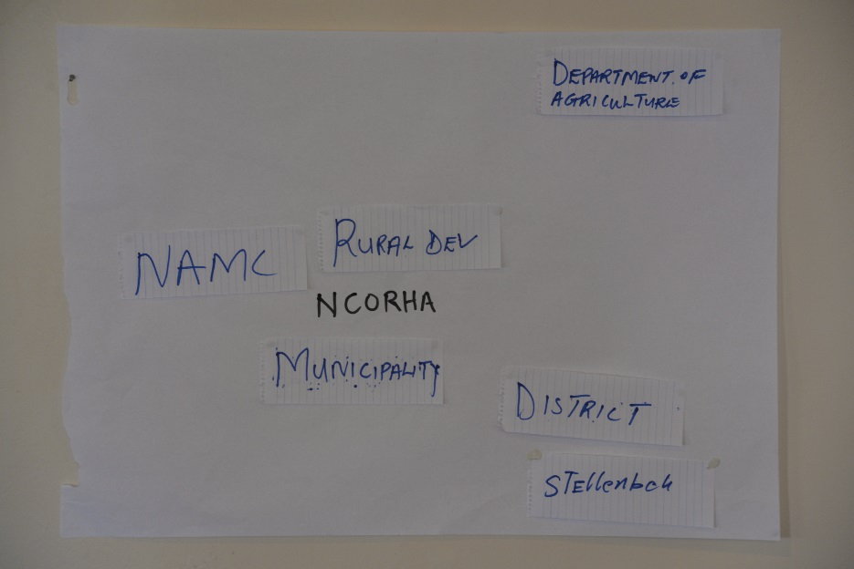

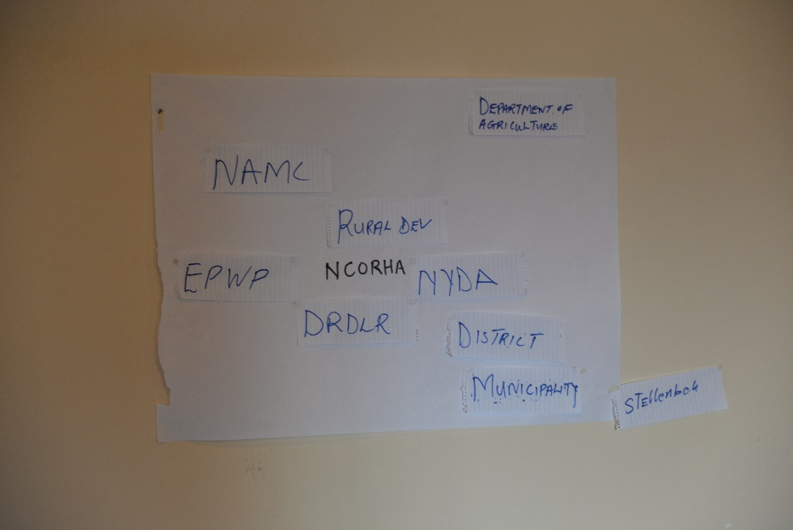

Abathathi-nxaxheba baseNcorha babonise unxibelelwano namaziko amathandathu kuphela abawabona njengawona azibandakanyayo ekusebenzisaneni nale fandesi. Bathi babona obona budlelwane buqinileyo ibobo banabo ne-Rural Development, uMasipala ne-NAMC (National Agricultural Marketing Council). Xa bejonga amanye amasebe abanganxibelelana nawo, bacebise ukuba kunganexabiso elongezelekileyo ukwandisa unxibelelwano ngokuqinisa ubudlelwane ne-Expanded Public Works Programme (EPWP), i-National Youth Development Agency (NYDA) ne-Department of Rural Development and Land Reform (DRDLR). Ngokuchaseneyo, oku kungabangela ubuyekeyeke kubudlelwane obukhoyo ne-NAMC noMasipala. Ubudlelwane ne-Rural Development busashiyeke buqinile kodwa obo be-Department of Agriculture, uMasipala wenqila ne-Stellenbosch University (SU) busahleli buthe qelele.

Iziphumo zakuGxwalubomvu

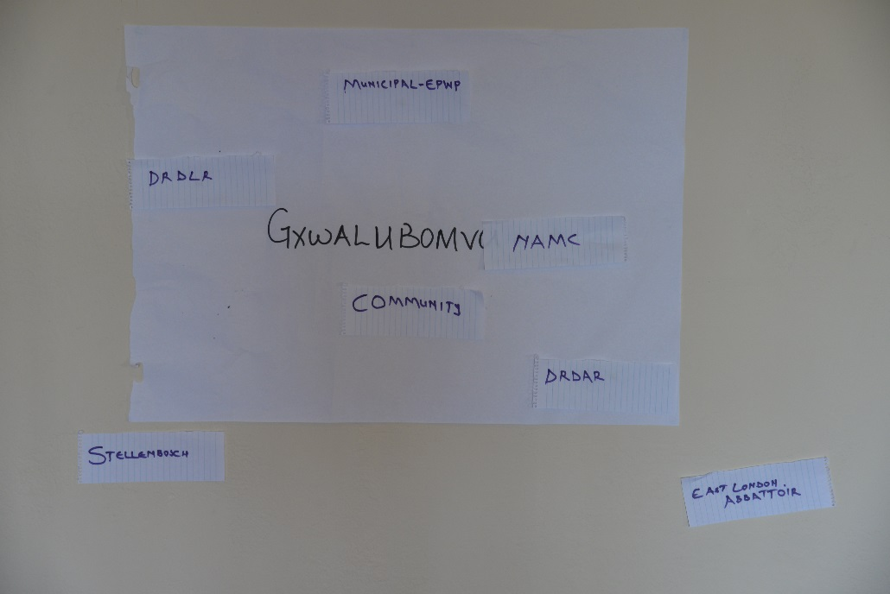

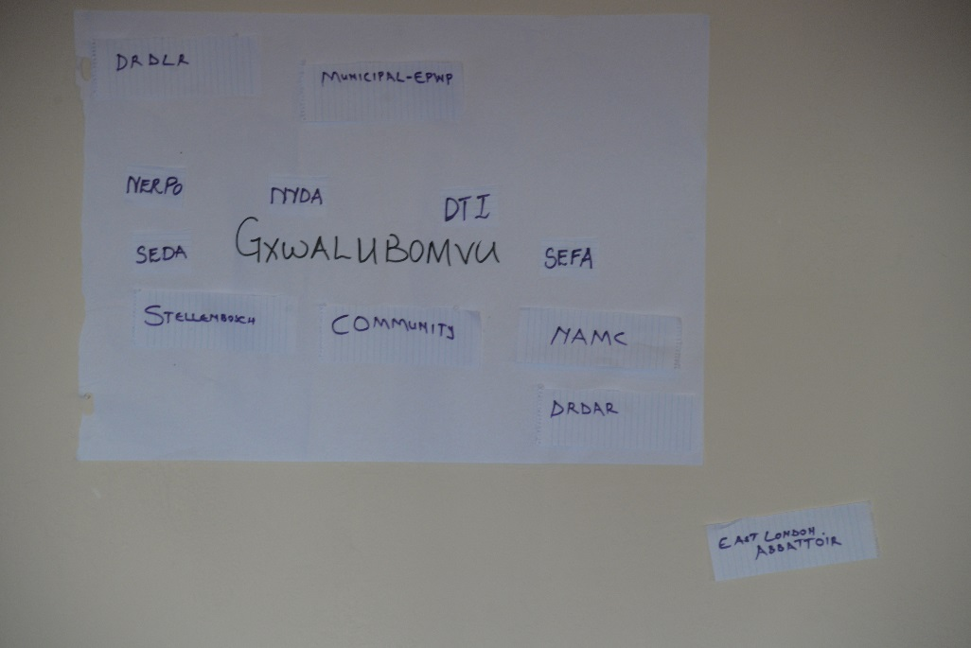

NjengaseNcorha, abathathi-nxaxheba bakuGxwalubomvu babonise unxibelelwano olumbalwa namaziko abawabona njengawona azibandakanyayo ekusebenzisaneni nefandesi. Oku kuquka ubudlelwane obuqinileyo noluntu, i-NAMC ne-DRDLR, ubudlelwane obuyekeyeke ne-EPWP obuza ngoMasipala ne-Department of Rural Development and Agrarian Reform (DRDAR) nobudlelwane obuthe qelele ne-SU nesilarha saseMonti. Xa bejonga amanye amasebe abanganxibelelana nawo, abathathi-nxaxheba bacebise ukwandisa oku ngamandla ngokuthi bakhe ubudlelwane obutsha nala maqumrhu alandelayo: i-National Emergent Red meat Producers Organisation (NERPO), i-National Youth Development Agency (NYDA), i-Department of Trade and Industry (DTI), i-Small Enterprise Development Agency (SEDA) ne-Small Enterprise Finance Agency (SEFA). I-DTI, SEDA ne-SEFA bezikade zijongwe njengezona bezinokuba yimithombo yokongeza imali efandesini (jonga ngaphantsi). Ubudlelwane ne-DRDLR ne-NAMC buye bancipha kolu nxibelelwano lutsha ngelixesha buqina ngamandla ne-SU. Ubudlelwane namanye amaqumrhu amathathu abutshintshanga.

Iziphumo ze-Ikhephu

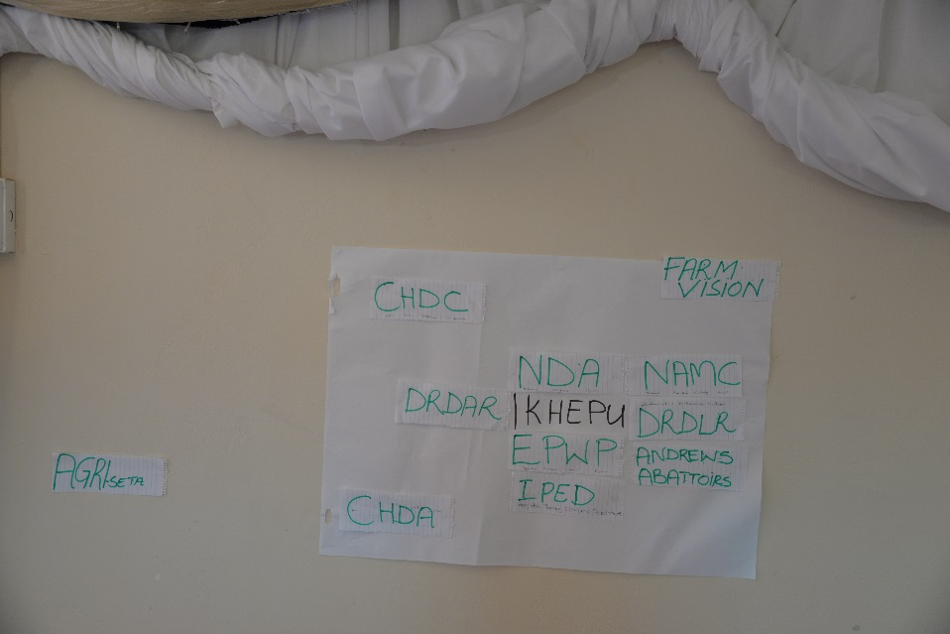

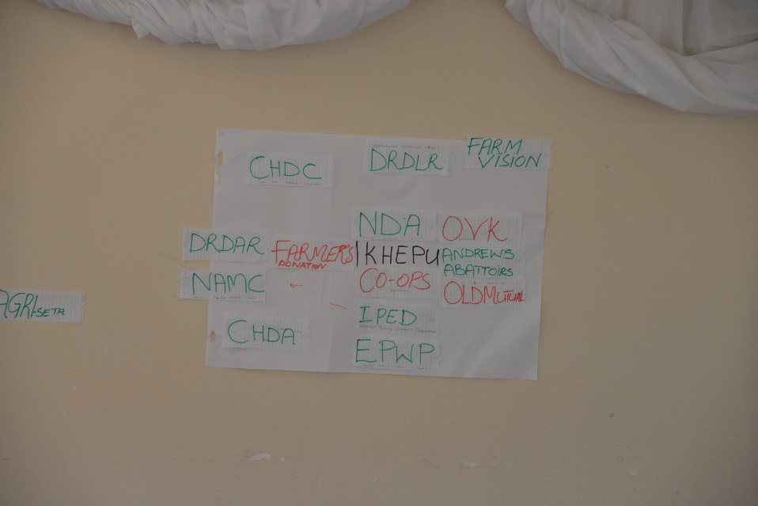

Xa kuthelekiswa neefandesi zamafama asakhasayo, abathathi-nxaxheba abasuka e-Ikhephu babonise unxibelelwano olubanzi (abadlali abali-11) namaziko abawabona njengawona azibandakanyayo ekusebenzisaneni nefandesi. Ubudlelwane obukhoyo obuqinileyo babubona ibobo be-National Development Agency (NDA), i-Integrated Planning and Economic Develop (IPED) i-programu yeChris Hani District, i-NAMC, i-DRDLR, i-DRDAR, i-EPWP ne-Andrew’s Abattoir. Kukhona nobudlelwane obuthe qelele ne-The Charity Farm Vision, Chris Hani Development Agency (CHDA) ne-Local Council (CHDC). Kukhona nobudlelwane obuthe qelele kakhulu ne-Agricultural Sector Education Training Authority (AgriSETA). Xa bejonga, abanye abadlali abangathanda ukwakha ubudlelwane obuqinileyo nabo ngamafama neminye imibutho kwalapha ngaphakathi kwi-Ikhephu (njengendlela yokuphucula ithuba lokuphila kwefandesi ixesha elide – jonga ngaphantsi), kwakunye neenkampani ezizimeleyo ezifana no-Old Mutual Insurance ne-Oos Vrystaat Kaap Coop (OVK). Obu budlelwane butsha busisisekelo esingaba sisisombululo abangasithathela ingqalelo ukunciphisa ubuthathaka kwifandesi (jonga ngaphantsi). Ngokuchaseneyo babona ubudlelwane obuyekeyeke namasebe karhulumente afana ne-NAMC, i-DRDLR ne-DRDAR, ngelixa ubudlelwane nawo onke amanye amaqumrhu engabonakalisi kutshintsha.

Ukuzikisa ukucinga ngeziphumo zokwakha okanye ukuphelisa ubudlelwane namanye amaqumrhu

Xa kuthelekiswa iziphumo kuzo zontathu ezi fandesi, kunika umdla ukuqaphela ukuba abathathi-nxaxheba babubona ubudlelwane ne-NAMC njengomdlali abanonxibelelwano nayo busibayekeyeke. Akucacanga ncam ukuba kwenziwa yintoni oku. Kungayanyaniswa nokuba mhlawumbi bayibona i-NAMC ibuthathaka ekuhanjisweni kweenkonzo, okanye yindlela yokuzikhwebula kwabo kuyo kuba besazi ukuba iifandesi zinikwe umyalelo wokuba zizimele emva kweminyaka emine zixhaswa, ngokoke babona kuyimfuneko ukuba bazifunele abaxhasi abatsha.

Bekunomehluko ocacileyo phakathi kweefandesi zamafama akhasayo ne-Ikhephu kubadlali abatsha ababongezileyo abanqwenela ukwakha ubudlelwane obuqinileyo nabo. Kwiifandesi zamafama asakhasayo abadlali abatsha ibingamaqumrhu aphantsi korhulumente okanye amasebe karhulumente, ngelixesha kwi-Ikhephu ibingamafama uqobo okanye iinkampani ezizimeleyo. Kucacile ukuba xa becinga ngokuqhubeka ixesha elide, iifandesi zamafama asakhasayo zisabona urhulumente njengoyena unoba negalelo elikhulu ngelixesha i-Ikhephu izimisele ukuphelisa ukuxhomekeka ngokuthi bazuze ngcono kwigalelo lamalungu abo ze oku bakuxabangele / ncedise ngegalelo elivela kwiinkampani ezizimeleyo.

*Izisombululo*

Ngokusekelwe kumsebenzi ebebewunikiwe bawenza, abathathi-nxaxheba bacelwe ukuba beze nezisombululo kubuthathaka neenkxalabo abaziqapheleyo ngokuthi batsale kumandla namathuba abanawo bakunxulumanise oku namasebe okanye imibutho ebebeyikhankanyile engabaluncedo ekuziseni izisombululo.

Abathathi-nxaxheba abasuka kwifandesi yamafama asakhasayo beza neengcebiso zokusombulula ezibufana: -

1. Baphinde bajonge umgaqo-siseko wabo benyuse imali yobulungu, kananjalo bacingisise isicwangciso soshishino (business plan) sabo.
2. Abathathi-nxaxheba bakuGxwalubomvu bacebisa ukunyusa imali yobulungu ibiyi-R850 ibe yi-R1000 ngenkomo kodwa abaseNcorha babe nobunzima ukuba ingaba yimalini na ekungafanela kunyuswe ngayo.
3. Bakhangele ezinye iindlela ezizezinye zokufumana imali kuquka nokucela kumasebe karhulumente, umzekelo, isebe lorhwebo noshishino (DTI) namaqumrhu afumana imali kurhulumente, umzekelo, Small Enterprise Funding Agency (SEFA) and Small Enterprise Development Agency (SEDA).
4. Babeke imiqathango engqingqwa ekwamkeleni iinkomo efandesini, kungavunyelwa ukufakwa kweenkomo ezikumgangatho ophantsi ezizobangela inkcitho ekutyeni nasemalini. Kananjalo, babengqingqwa ngokusikela iinkomo ixesha emazilichithe zisefandesini ibe ngumlinganiselo obekiweyo weenyanga ezintathu kuphela.
5. Abathathi-nxaxheba kuzo zontathu ezi fandesi babonise umdla ekujongeni iindlela abanokuthi bazenzele okwabo ukutya kwemfuyo ukunciphisa ukuxhomekeka ekutyeni okuthengiweyo nabakufumana kurhulumente. Bacebisene nangokujonga ukuba abanakufumana umhlaba eluntwini ze bazilimele umbona nokunye ukutya kweenkomo okufana neLusini.
6. Abathath-nxaxheba baku-Gxwalubomvu bacebisa ngokuthenga umatshini wokusila umbona bazixubele ukutya njengoko besenza abase-Ikhephu ngoku besenemali ekhoyo evela kuleyo ibibhatalelwe ubulungu.

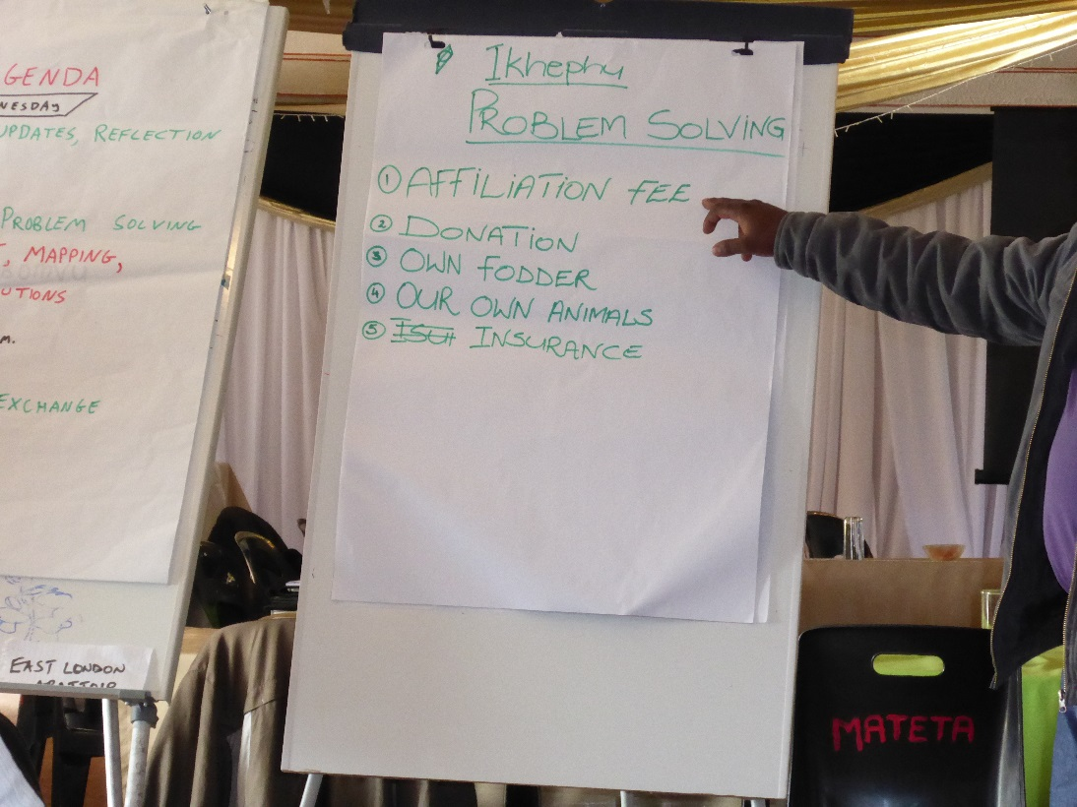

*Abathathi-nxaxheba abasuka e-Ikhephu benika intetho ngeendlela zokusombulula eminye yemiba ephambili eyayanyaniswa nokusebenza kwefandesi.*

Abathathi-nxaxheba abasuka e-Ikhephu beze nezisombululo ezibini ezintsha ezitsala umdla zokwenyusa imali-ngeniso zinciphise nengozi okanye ungcipheko engazifumana ikuyo imfuyo:-

1. Umntu ngamnye kumafama ali-156 kwifandesi yabo unikela ngenkomo okanye okunye okusondele kwixabiso lenkomo ukwakha umhlambi, lo mnikelo ugcinwa apha efandesini ube ngowombutho. Imali-ngeniso kwintengiso yezi nkomo zomnikelo ithathwa isetyenziswe ukuhlawula iindleko zefandesi ezifana nokutya, amayeza, iindleko zokubonwa ngugqirha wezilwanyana xa zigula nezinye izinto ezincinci eziyimfuneko.
2. Ukubakho komshwalensi weenkomo ezisefandesini. Okwangoku, ifandesi nganye inomgaqo-siseko othi amafama azisa iinkomo efandesini akwenza oko ngomngcipheko wawo, okutsho ukuthi ifandesi ayinatyala ngokugula okanye ngokufa kwenkomo eziswe kuyo. Abanini zinkomo abawuthandi lo mthetho. Bakholelwa ekubeni ukungakhathali efandesini nguyene nobangela welahleko, kuquka ukufa ngenxa yenkathalo engekhoyo okanye ilahleko ngenxa yobusela. Ukongeza imalana encinci kwimali yobulungu ingenza iifandesi zikwazi ukuthatha umshwalensi wokunceda ukubuyisela umfama kuyo yonke ilahleko emehlelayo.

*IIngcinga zabathathi-nxaxheba ngexabiso lewekshophu:*

Xa bebezikisa ukucinga ngabakwenzileyo, ezona zinto zingundoqo abaziphakamisileyo zezi:-

1. Bonke abathathi-nxaxheba bavumelane ukuba balivuyele ithuba abalifumene kwiwekshophu lokudibana namagosa, abagqibe ukufunda bezoqeqeshelwa umsebenzi, namafama asuka kwezinye iifandesi babelane ngamava neendlela zokusebenza. Ingakumbi, abathathi-nxaxheba abasuka kumafama asakhasayo abalule ukuba afunde lukhulu kumagosa asuka e-Ikhephu ebebewabona njengabantu abanolwazi oluthe xhaxhe ngemiba yokukhathalela imfuyo efana nokunqumla iimpondo zenkomo nokuxutywa kokutya kwemfuyo.
2. Omnye wabathathi-nxaxheba osuka kumafama asakhasayo uvakalise inkxalabo nokungathembi ncam ukuba lungaba sisiseko liqhubekeke njani na olu lwazi nolu nxibelelwano lwakheke kule wekshophu. Bebeze bezithembise ukuba le wekshophu yeyoqeqesho enjongo ikukuphucula izakhono zabo zobuchwephesha, ngoko ke banomdla wokubona ukuba bangaqhubeka besabelana njani ngolwazi ukuze lusetyenziswe nakwiifandesi abakuzo.
3. Abathathi-nxaxheba abaliqela balivuyele ithuba lokuphakamisa baxoxe ngeemfuno zabo zophuhliso noqeqesho ngokubanzi.
4. Ngokwayamene noku, abathathi-nxaxheba ababini baphakamise umbuzo bebonisa umdla wokuqhubela phambili ngezifundo zabo besebenzisa ezi projekthi njengezo banokuzenza kuphando abanokulwenza needyunivesithi.

Omnye umba ophambili oye wavela ezingxoxweni ibe ngowokuba abathathi-nxaxheba abavela kwiifandesi zamafama asakhasayo bazive befunde lukhulu kunxulumano ababenalo nabathathi-nxaxheba abasuka e-Ikhephu kangangoba bangathanda ukundwendwela le fandesi ukuze bafunde banzi. Ngokungakhange kube bekucetyiwe, kuye kwagqitywa ekubeni kundwendwele ifandesi i-Ikhephu emva kwemini ngosuku lesithathu nelilelokugqibela lewekshophu (15/09/16) ngokuququzelelwa ngumanejala wefandesi (jonga iifoto kwikhasi lonxibelelwano uFacebook).

**Uvavanyo lewekshophu ngokubanzi**

Xa sisenza olu vavanyo, kubalulekile ukuba sijonge ukuba ingaba le wekshophu iziphumezile na iinjongo ebizisekele ukuziphumeza, ingaba ezi njongo ibiziinjongo ezingaphumezeka, nokuba zeziphi izinto ezingabe zibe nefuthe kwiziphumo zewekshophu. Imiba emibini ephambili engabe ibe nefuthe kokuphunyezwe yiwekshophu kuquka: -

*Abantu ebebekhona.* Injongo yale wekshophu ibikukuba ibe liqonga lokuva nokubona indlela amafama azibona ngazo ezi fandesi. Eneneni, abantu abaninzi abazileyo ibingamagosa, ekucingeka ukuba bebecinga ukuba yiwekshophu yoqeqesho ejongene nezifundo ezingobuchule bokuphatha ifandesi ezifana nokuxutywa kokutya kwemfuyo. Akwazeki ukuba olu qhawuko lonxibelelwano lenzeke njani njengoko uluntu belundwendwelwe kwiveki ephelileyo ukupapasha iwekshophu kukhuthazwa namafama ukuba eze. Ngekube ngeshwa ukuba ukuza kwamagosa amaninzi kunciphise ukuza kwamafama (izithuthi zokuya nokubuya zilinciphisile inani labo bakwaziyo ukuza). Kubonakala nokungathi iimvula zokuqala zentwasa-hlobo ezifike ngaphambili kwexesha kwiveki ephambi kwewekshophu zibe negalelo ekunciphiseni inani lamafama njengoko ebeqalisa ukulima. I-Ikhephu ibiyeyona inamafama ambalwa azileyo kangangokuba ngenye imini kwakungekho noba abemnye umfama osuka kule fandesi. Oku kubambalwa kwamafama azileyo kwifandesi nganye ishiya umbuzo wokuba ingaba iziphumo zoluphando zizibonisa ngokufanelekileyo na izimvo zamafama. Mhlawumbi amafama ngebone imiqobo/ izithinteli nobuthathaka beefandesi ngeliso elingelilo elobuchwephesha, bagxile kakhulu empilweni nasezintweni ezibulala mfuyo, iindawo apho banokuthengisa kuzo imfuyo yabo namaxabiso ekuthengiswa ngawo*.*

*Ukungakwazi ukuthatha imiboniso yabathathi-nxaxheba.* Enye yeendlela eziphambili le wekshophu ebijonge ukuzisebenzisa ibikukuthatha imiboniso yabathathi-nxaxheba (kuquka abaphandi nabathathi-nxaxheba uqobo). Oku ngekukwenze lula ukuthwetyulwa kwesimo nezimvo zabathathi-nxaxheba kushicilelo olubonwayo noluviwayo engebejonge kulo xa bebuyele emva bezikisa ukucinga. Ngeyibe luncedo kakhulu ukubonisa isimo ukuba besinjani ngaphambili nangemva kwimiboniso, njengoko ibizakuthatha ibonise ngokucacileyo izizathu zezinye izinto ebebezicinga ngotshintsho nonxibelelwao nabadlali abangabanye.

*Ukuphunyezwa kweenjongo zeprojekthi*

Ekuzikiseni ukucinga ekubeni ingaba iprojekthi izifezekisile na iinjongo ibizibekele zona, kungatshoko ngcono ukuthi imiqobo eme endleleni yokusebenza kakuhle kweefandesi ishukuxwe ngokucacileyo nangona ibiliqela labathathi-nxaxheba abanokuba beze noluvo kwicala elahlukileyo kunelo bekumiselwe lona. Ngokwendima ye-*action research* ekuphuculeni unxibelelwano kwabo bachaphazelekayo ukuze kuphucuke iindlela eziqhuba ngayo iifandesi, uluvo ngokugxila ekwabeleni ngolwazi luyabethana. Ingaba abathathi-nxaxheba bebezibandakanye ngokulinganayo kulo mba? Izimvo eziphuma kubathathi-nxaxheba bamafama asakhasayo zicacisa mpela umdla nexabiso abalidibanisa nokunxulumana nabathathi-nxaxheba base-Ikhephu. Kodwa kushiyeka kungathembeki ncam ukuba ingaba bonke abathathi-nxaxheba base-Ikhephu bona balubona olu nxibelelwano lunenzuzo kubo na njengoko luyiyo kwabanye. Nangona amagosa ase-Ikhephu ebonakala ezimisele ukunxibelelana noogxa babo abakwifandesi zamafama asakhasayo, amafama agqibeleleyo ase-Ikhephu awabonakalisi kuziveza indlela acinga okanye ava ngayo. Nangona bebenolwazi ngewekshophu bekwazi nokuzizela, mnye kuphela umfama ogqibeleleyo osuka e-Ikhephu owezayo kwaye naye weza usuku olunye kuphela. Wayegxile kuphela ekufumaneni inkxaso ebambekayo enomdla omncinci kuluvo lokusombulula iingxaki ngokwabelana ngolwazi namanye amafama. Waye wacacisa ukuba asikuko ukuba amafama agqibeleleyo ase-Ikhephu akuchasile ukunceda afundise amafama asakhasayo njengoogxa babo, koko baxakekile kwaye banezinto ezininzi ezithi gqi ekufuneka bejongane nazo ngokukhawulezileyo. Oku kubonisa ukuba indlela yokucinga esekelwe kuluvo lokuba amafama anobuchwephesha nolwazi ngorhwebo anokuba nomnqweno wokwabelana ngolu lwazi namafama asakhasayo ibiyingcingane engenakufezekiswa. Ngokuqinisekileyo, iyawanciphisa amathuba okuqhubeka kunxibelelwana phakathi kwamaqela ohlukeneyo amafama naziphina izixhobo ezinokwakhiwa ukuxhasa ukuphumeza oku. Okusalayo, ithuba lokuqhubeka kusabelwana ngolwazi neendlela ezizizo zokusebenza phakathi kwamagosa avela kuzo zonke iifandesi naphakathi kwamafama asakhasayo akwiifandesi yiyona ndlela abathathi-nxaxheba abayibona kululutho ukuyilandela. Ngenxa yemigama emide phakathi kwezi fandesi nokunqaba kwezinto ezikhwelwayo ingakumbi kwicala lamafama asakhasayo, kwavunyelwana ukuba ukwabelana ngolwazi kwikhasi lonxibelelwano yiyona ndlela yokuphumeza oku. Abathathi-nxaxheba bacebisa ukuba kuvulwe ikhasi ku-Facebook (igama lekhasi / ilinki seyinikiwe ngentla), lathi lavulwa ngumfundi wezobugqirha (PhD) wase-SU.

**Iziphakamiso namanqaku ekunokunyahelwa kuwo**

1. Ukusasazwa kwale ngxelo kwababandakanyekayo abaphambili ngokuchazwe ngabathathi-nxaxheba ngexesha kuqhubeka iwekshophu, kuquka: i-NAMC, DRDAR, DRDLR, NERPO, NDA, CHDA, DTI, SEDA ne-SEFA (CU) nokuthumela kwikhasi lonxibelelwano u-Facebook. Ingxelo mayiguqulelwe esiXhoseni ze ifandesi nganye ifumane ikopi.
2. Kukhuthazwe ukuqhubeka ngonxibelelwano phakathi kwamafama namagosa ebeze kwiwekshophu ku-Facebook njengendlela yokwabelana ngolwazi. Kukhuthazwe ukubandakanyeka luluntu lonke ebelukhona (abafundi abenza izidanga zobugqirha kwezolimo e-SU).
3. Izifundiswa zase-SU zilandelele ngoqeqesho, uphuhliso nezidingo zophando eziphakanyiswe ngabathathi-nxaxheba kwiwekshophu. Oku kunganceda ukusombulula ezinye izidingo ezingokunqongophala kwezakhono nobuchwephesha njengoko kuphakanyiswe kwiwekshophu. Oku kunganceda nokucacisa uhlelo lokuqhubeka ngomsebenzi wophando phakathi kwe-SU noluntu.
4. Ukuququzelela unxibelelwano olungcono phakathi kweefandesi namaqumrhu iifandesi azibona enonxibelelwano oluqinileyo nawo. Oku kungaphantse kuphunyezwe ngabaphandi abaphambili kule projekthi ngokuqinisekisa ukuba la maqumrhu aphambili ayayifumana le ngxelo. Kodwa, oku kufuneka kukhatshwe yimizamo eqhubeka njalo kwiifandesi uqobo ukujonga ukuba ngubani na onoxanduva lokwakha olu nxibelelwano nangokuqhubeka besebenza namaziko asecaleni afana ne-SU anokwazi ukubancedisa koku.
5. Ukulandela umgaqo wokuthathwa komshwalensi ziifandesi zonke ukunceda ukubuyisela amafama xa ehlelwe yilahleko yemfuyo. Oku kungaphunyezwa ngokonyusa kancinci kwimali yobulungu.
6. Ukujonga ukuba lingakho na ithuba lokwakha umhlambi e-Ikhephu ozokunceda ukuba ifandesi ihlale inemali ezakhele yona ngokukokwayo.